Lesson 11 – Review Part 2
(Lección 11 – Revisión parte 2)

Fill in the blank with the English word. Use an English translator if necessary.
(Complete el espacio en blanco con la palabra en inglés. Utilice un traductor de inglés si es necesario.)

- John and I play outside. ______________ play outside.
- This is my father’s father. He is my _________________________.
- I am her brother. She is my __________________________.
- He is crying so he is _______________.
- My father won money so he is ________________________.
- I stayed up all night studying so I am ______________________.
- I didn’t eat all day so I am _________________________.
- We can go to the park. Come with ______________.
- My mother is coughing and has a fever. My mother is ________________.
- I was at work for 16 hours. It was a __________________ time.

Answers on next page (respuestas en la página siguiente)

- We
- Grandfather
- Sister
- Sad
- Happy OR Excited OR Surprised
- Tired OR Sleepy
- Hungry
- Us
- Sick
- Long

Order the words correctly. Use an English translator if necessary.
(Ordene las palabras correctamente. Utilice un traductor de inglés si es necesario.)

- sick / are / they ________________________________________________
- is / father / excited / my _________________________________________
- surprised / are / you / now _______________________________________
- baby / is / the / old / not _________________________________________
- long / how / dog / is / the ________________________________________
- morning / sleepy / I / in / am / the _________________________________
_____________________________________________________________
- mother / are / today / and / the / sad / father _______________________
_____________________________________________________________

Answers on next page (respuestas en la página siguiente)

- They are sick. OR Are they sick?
- My father is excited.
- You are surprised now OR Are you surprised now?
- The baby is not old.
- How long is the dog? OR The dog is how long?
- In the morning I am sleepy. OR I am sleepy in the morning.
- The father and mother are sad today. OR Today the father and mother are sad.

Write 4 sentences to tell about the picture using pronouns, family relationships, emotions, and adjectives.

(Escribe 4 oraciones para contar sobre la imagen usando pronombres, relaciones familiares, emociones y adjetivos.)

Example (ejemplo):

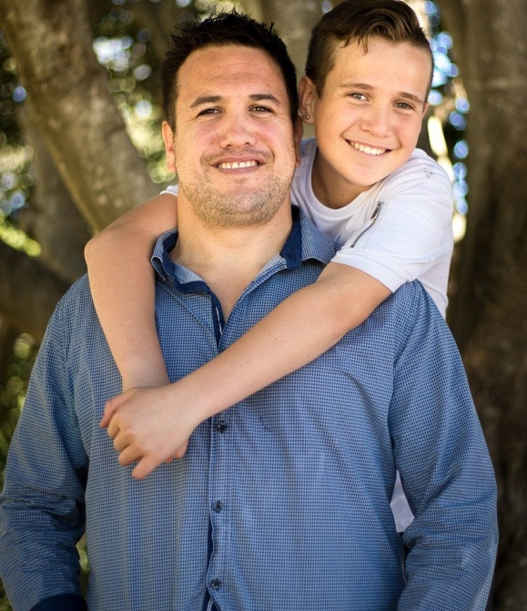

He is a father. (El es padre.)
He is happy. (Él es feliz.)
The son is on him. (El hijo está sobre él.)
The father is tall. (El padre es alto.)

1.

___________________________________________________________________

___________________________________________________________________

___________________________________________________________________

___________________________________________________________________

2.

___________________________________________________________________

___________________________________________________________________

___________________________________________________________________

___________________________________________________________________
3.

_

__________________________________________________________________

___________________________________________________________________

___________________________________________________________________

___________________________________________________________________
4. Más difícil

___________________________________________________________________

___________________________________________________________________

___________________________________________________________________

___________________________________________________________________
Answers on next page (respuestas en la página siguiente)
These are possible answers. Others may exist.
(Estas son posibles respuestas. Pueden existir otros.)

- She is a mother. She is happy. The daughter is hugging (abrazando) her. The daughter is young.

- He is a grandfather. He is happy. The grandfather is old. She is young.

- She is a mother. The daughter is angry. The mother and daughter are angry. The daughter is bad.

- The grandfather is happy and the grandmother is mad. He is surprised. She is hungry. The grandfather and grandmother are old.

Please consider donating to Acts 2:42 Ministries (https://www.paypal.com/fundraiser/charity/213230) to support the free English lessons. Thank you!

Considere hacer una donación a Acts 2:42 Ministries (https://www.paypal.com/fundraiser/charity/213230) para apoyar las lecciones de inglés gratuitas. ¡Gracias!

How do I get to heaven?
¿Cómo llego al cielo?
كيف أصل إلى الجنة؟
چگونه به بهشت ​​برسم؟

میں جنت میں کیسے جاؤں؟

Cennete nasıl gidebilirim?
मैं स्वर्ग कैसे पहुँचूँ?
我怎样才能上天堂？
English:
https://peacewithgod.net/
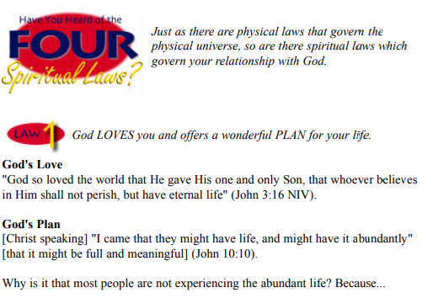
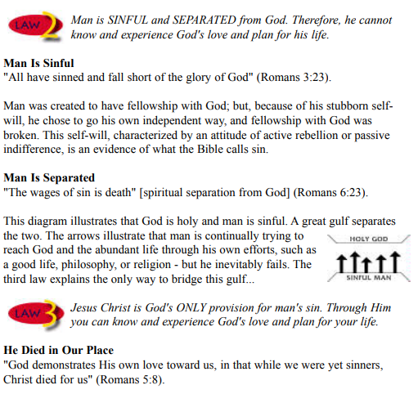
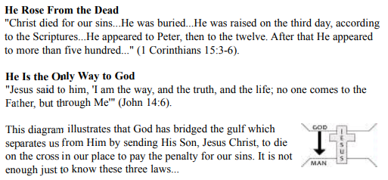

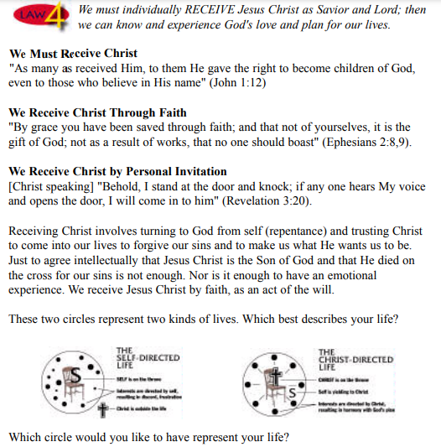
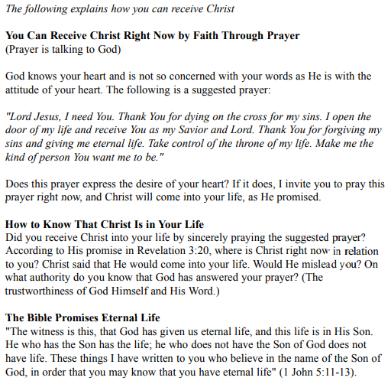
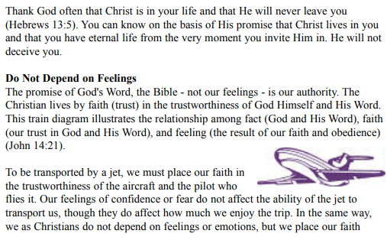
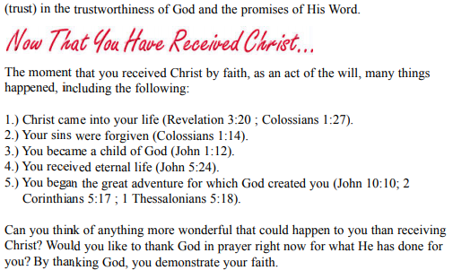
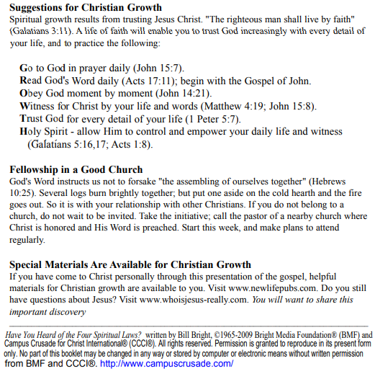
If you accepted Christ Acts 2:42 Ministries would love to know. Or if you have anything to share about these worksheets please let us know. nathand@242ministries.org
español:
https://www.youtube.com/watch?v=NRUqXwqTA8w
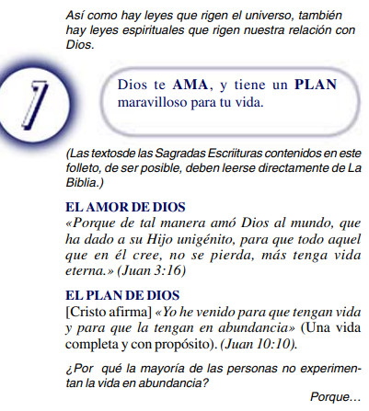
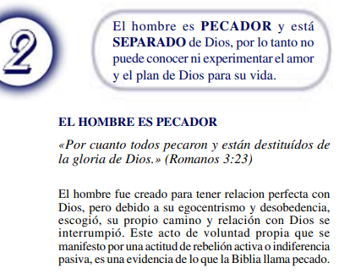
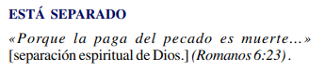
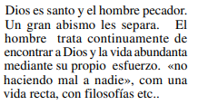
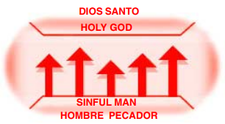
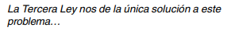
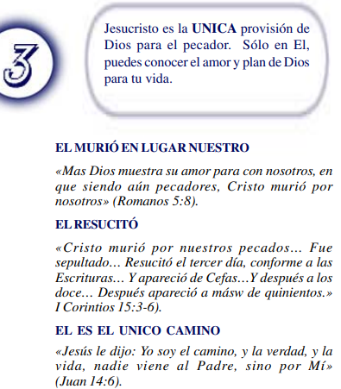
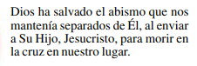
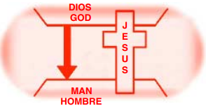

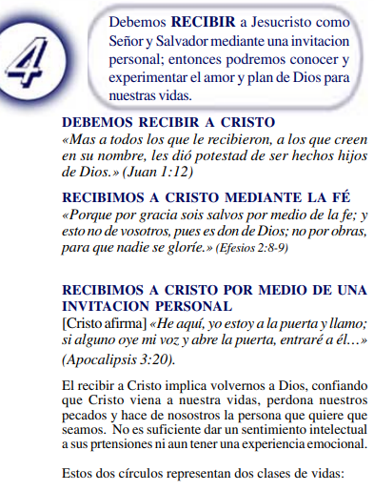
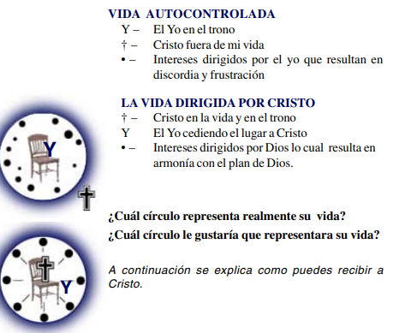

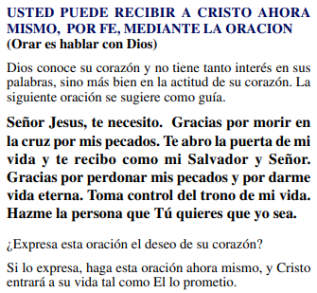
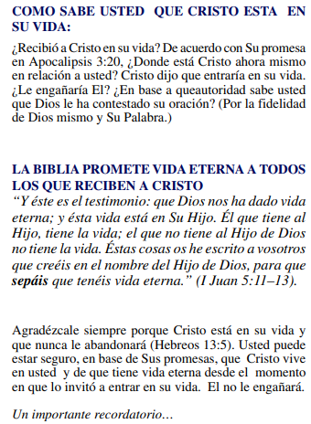
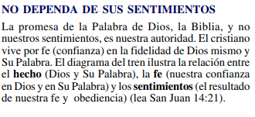
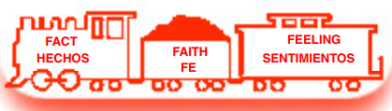
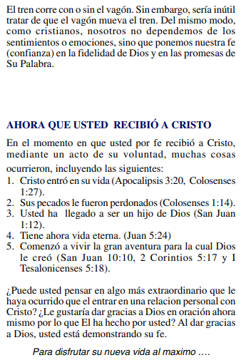
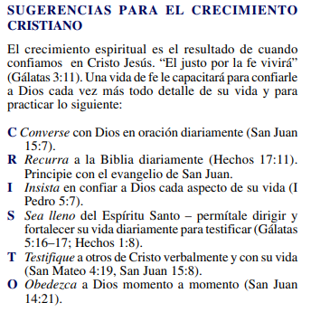
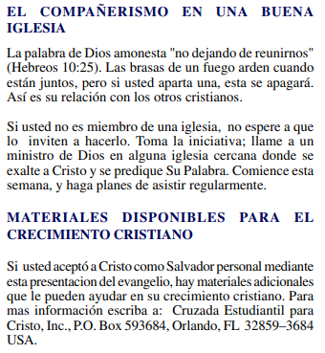
(Si aceptaste a Cristo Hechos 2:42 a Ministerios le encantaría saberlo. O si tiene algo que compartir sobre estas hojas de trabajo, háganoslo saber.)
nathand@242ministries.org
عربى:
https://www.youtube.com/watch?v=ePa_MElCi68
https://www.youtube.com/watch?v=o0GFYMPArW0
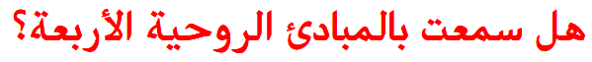
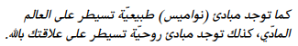
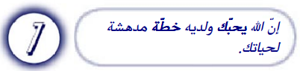
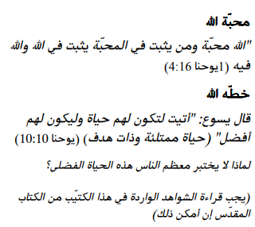

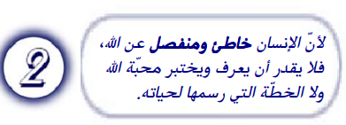
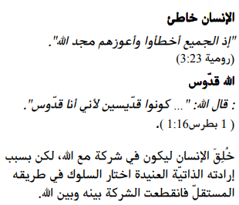
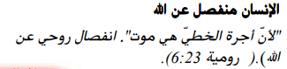

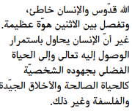
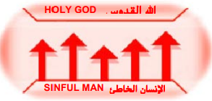
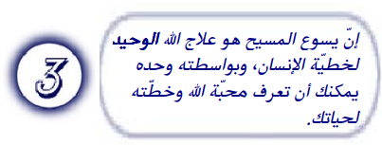
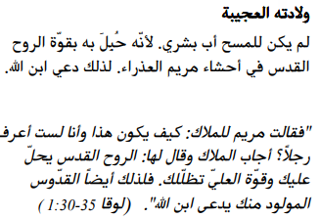
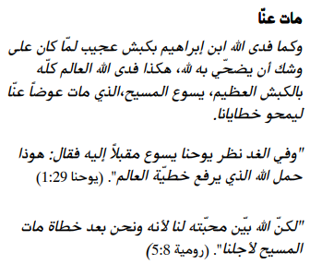
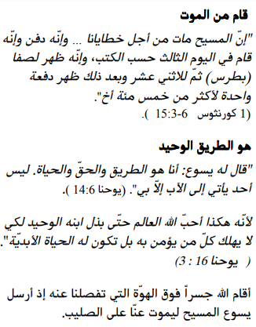

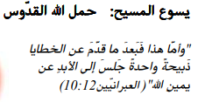
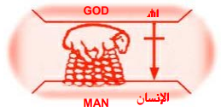
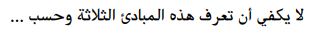
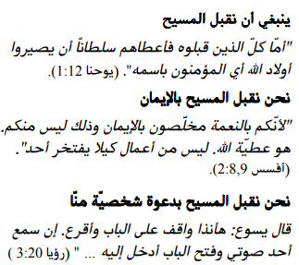
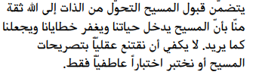
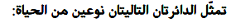
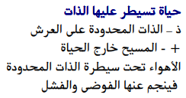
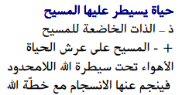
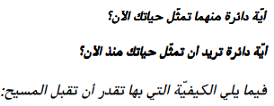
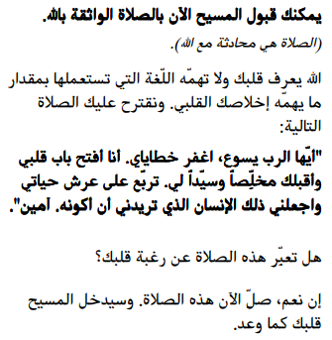
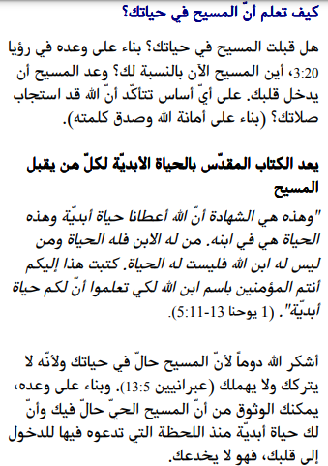
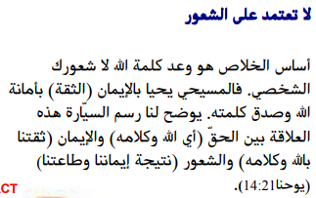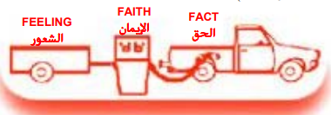
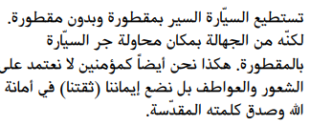
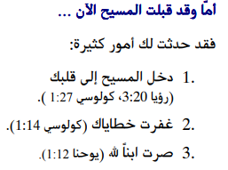

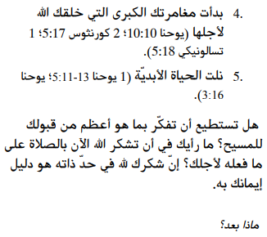
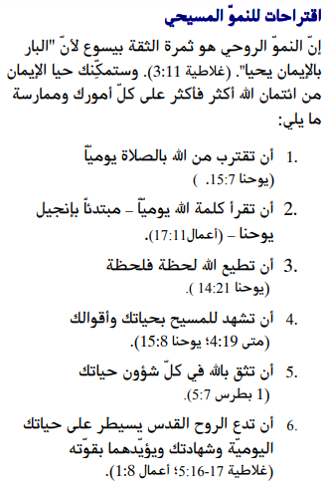
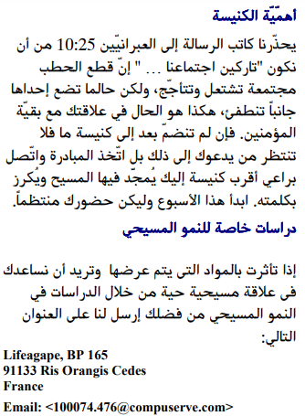

إذا قبلت المسيح فإن الخدمات تحب أن تعرف. أو إذا كان لديك أي شيء تريد مشاركته حول أوراق العمل هذه ، فيرجى إخبارنا بذلك.

nathand@242ministries.org
فارسی:https://www.youtube.com/watch?v=eWLsQ0DTsq0&t=12s

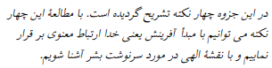
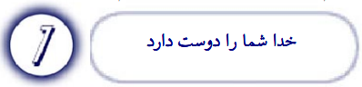
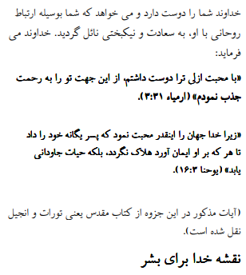
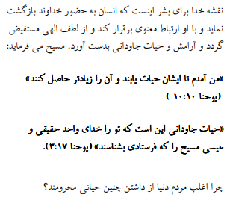
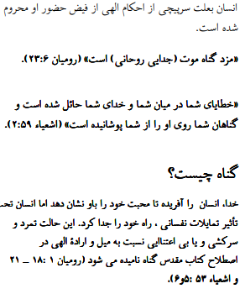
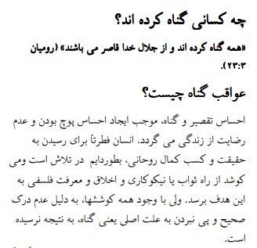
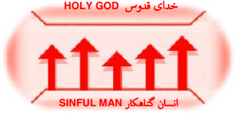
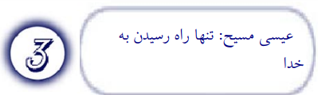
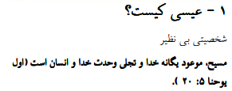
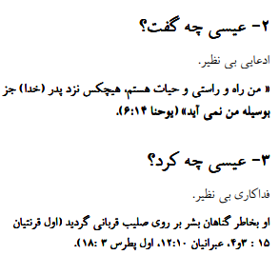
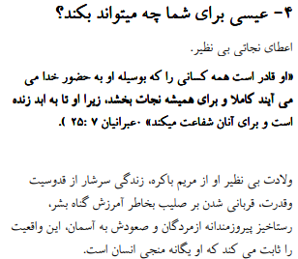
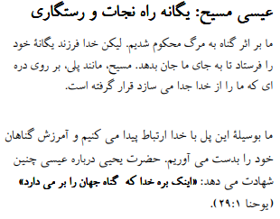
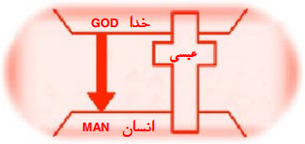
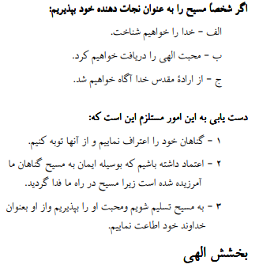
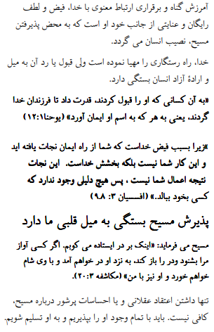
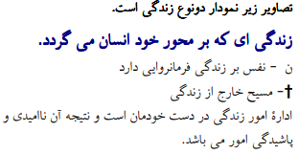
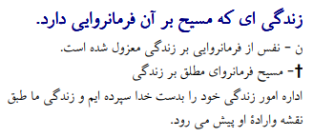
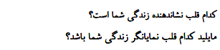
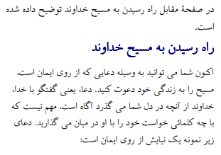

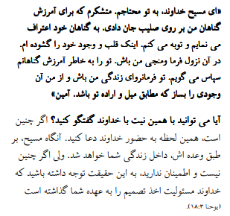
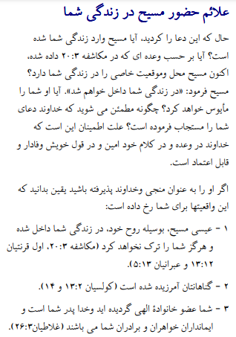
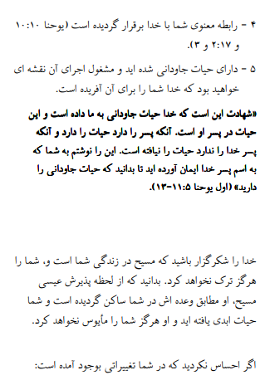
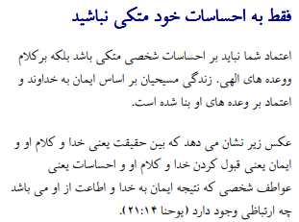
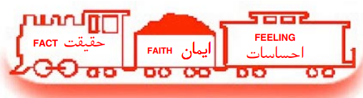
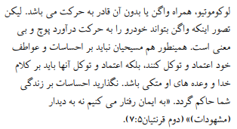
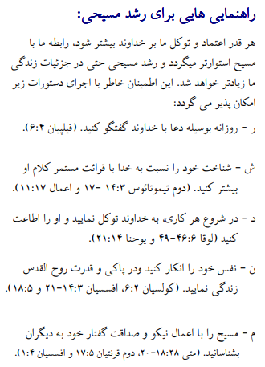
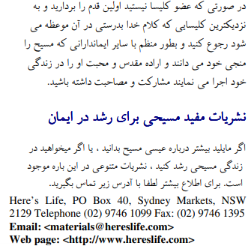

اگر مسیح را پذیرفتید اعمال رسولان 2:42 وزارتخانه ها دوست دارند بدانند. یا اگر چیزی برای به اشتراک گذاشتن در مورد این کاربرگ ها دارید ، لطفاً به ما اطلاع دهید

nathand@242ministries.org

اردو:
https://www.youtube.com/watch?v=6-GclzuUbxY
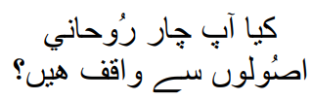
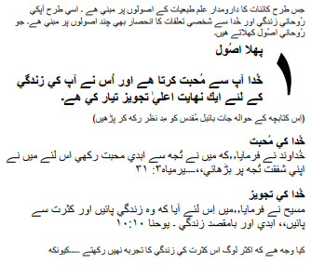
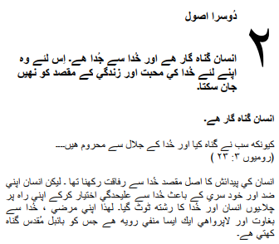
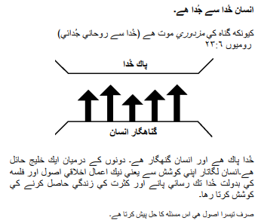
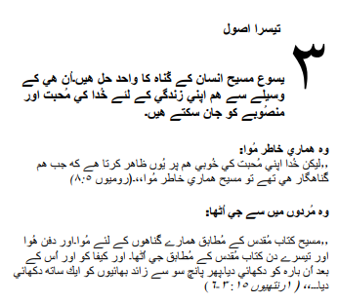
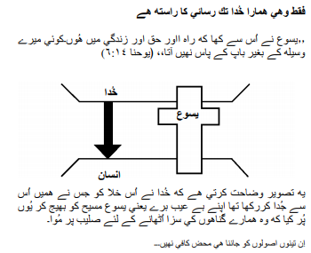
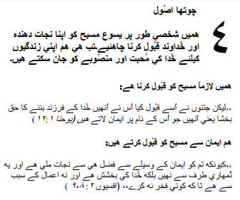
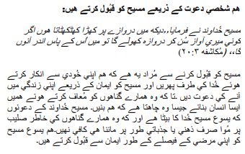
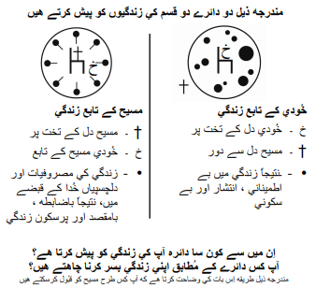
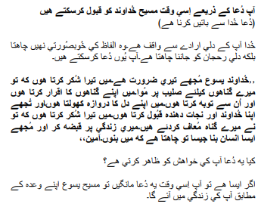
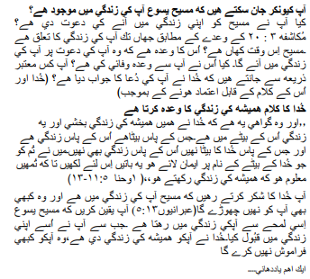

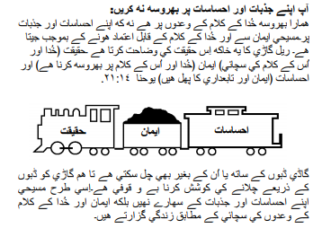
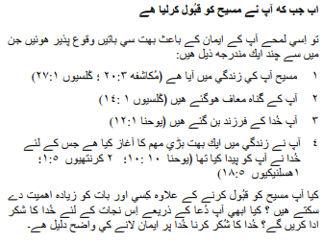
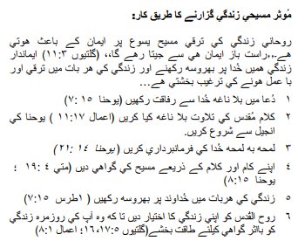
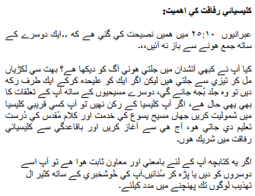

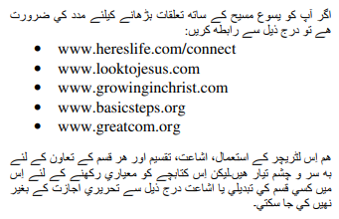

اگر آپ نے مسیح کے اعمال کو قبول کیا تو 2:42 وزارتیں جاننا پسند کریں گی۔ یا اگر آپ کے پاس ان ورک شیٹس کے بارے میں کچھ شیئر کرنا ہے تو براہ کرم ہمیں بتائیں۔

nathand@242ministries.org

Türk:
https://www.youtube.com/watch?v=6YwHd_PwOOQ
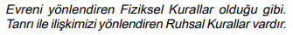
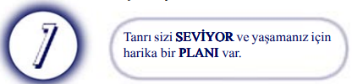
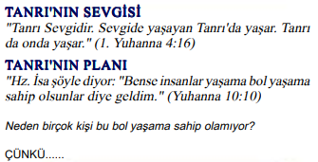
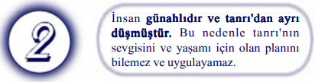
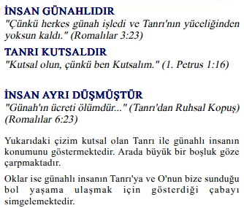
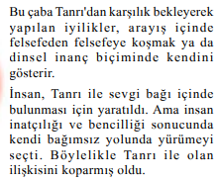
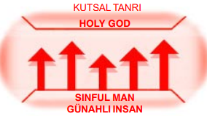
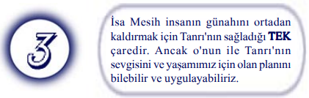
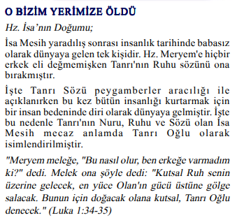

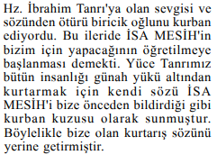

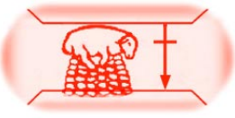
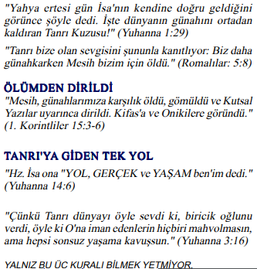
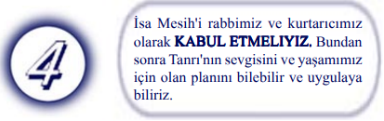
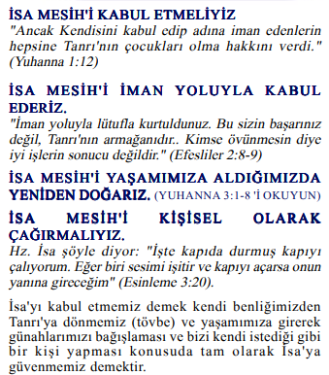
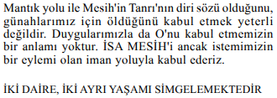
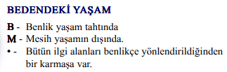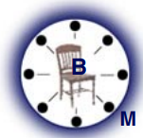

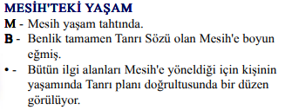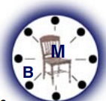

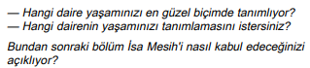

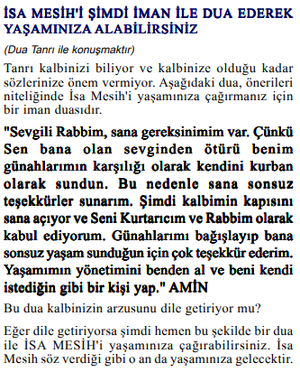

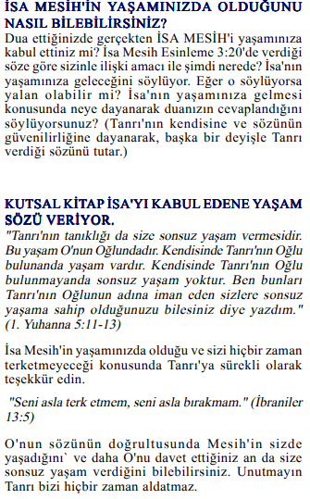
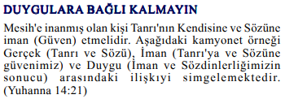
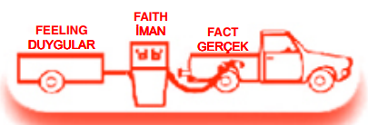
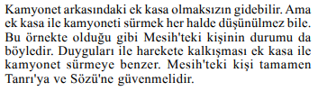
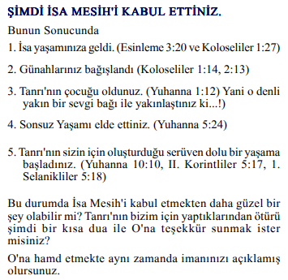
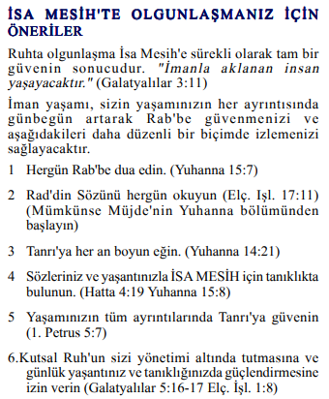
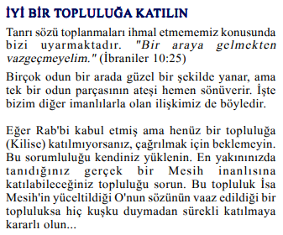

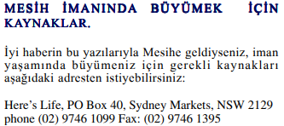

Mesih'in Elçilerinin İşleri 2:42'yi kabul ettiyseniz, Bakanlıklar bilmek ister. Veya bu çalışma sayfaları hakkında paylaşmak istediğiniz bir şey varsa lütfen bize bildirin.

nathand@242ministries.org

हिंदी:
https://www.youtube.com/watch?v=NR7AieVQI2A
https://www.youtube.com/watch?v=nmHla8doL5o
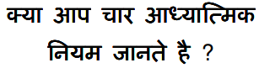
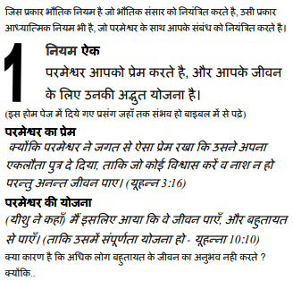

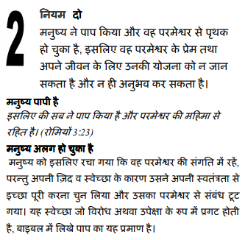
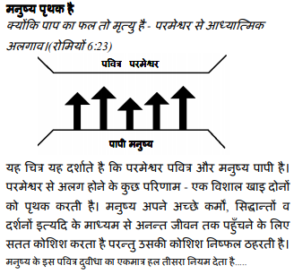

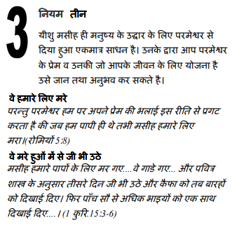
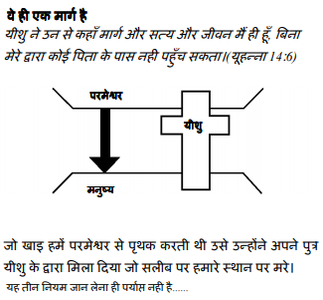
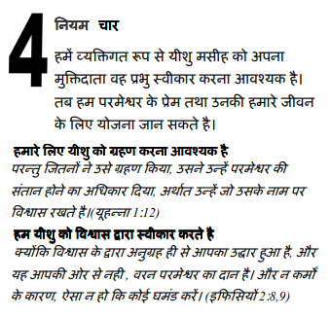
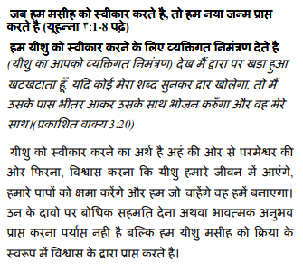
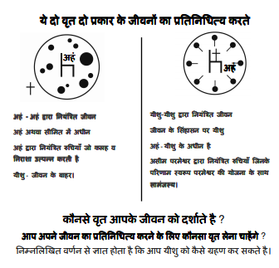
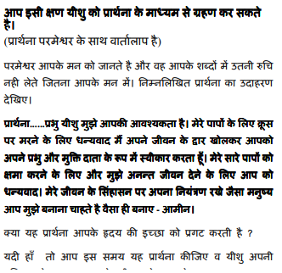

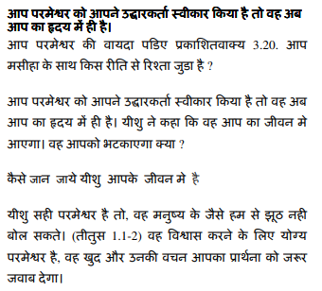
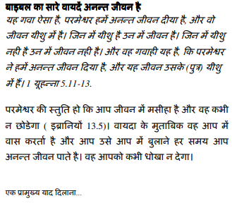

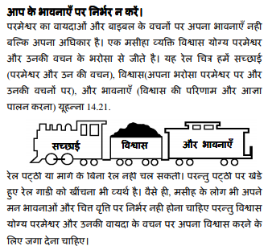
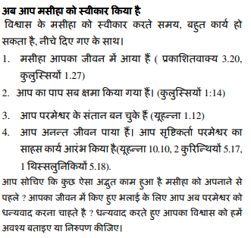

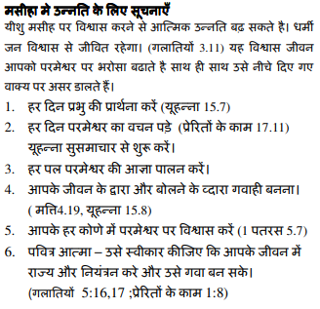
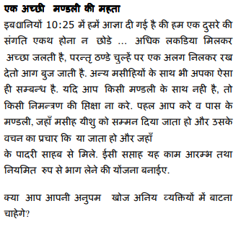

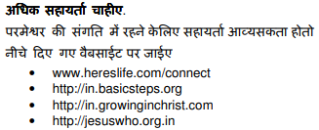

यदि आप मसीह के कामों को स्वीकार करते हैं प्रेरितों 2:42 मंत्रालयों को जानना अच्छा लगेगा। या यदि आपके पास इन कार्यपत्रकों के बारे में साझा करने के लिए कुछ है तो कृपया हमें बताएं।

nathand@242ministries.org
中国人:
https://www.youtube.com/watch?v=ebaT4PvcUEc
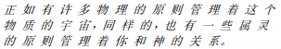
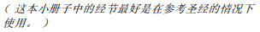
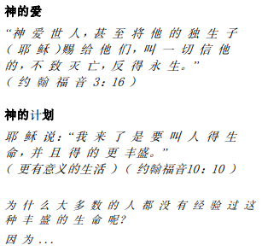

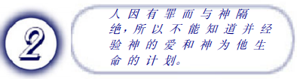
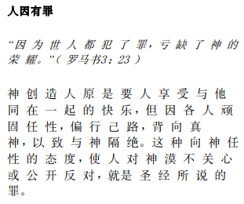
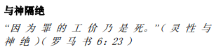
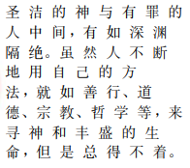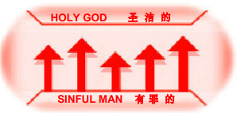
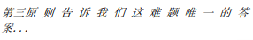

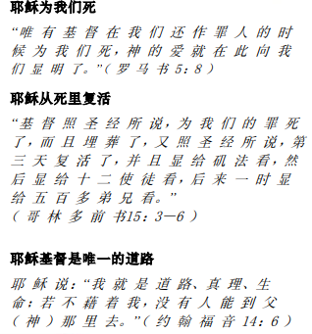
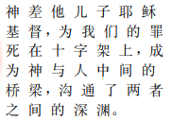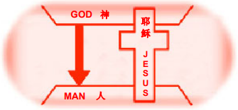

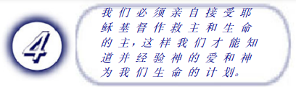
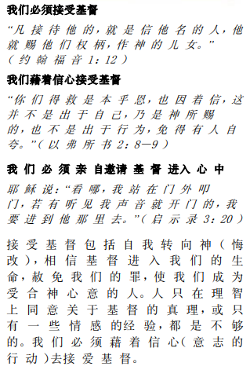
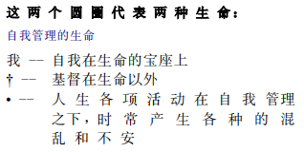

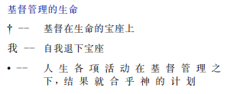
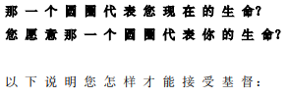
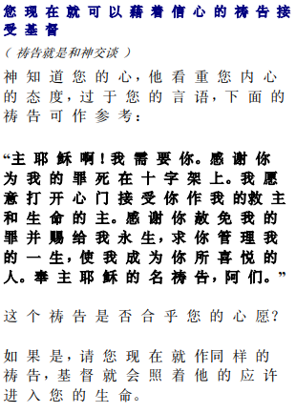

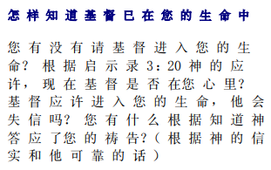
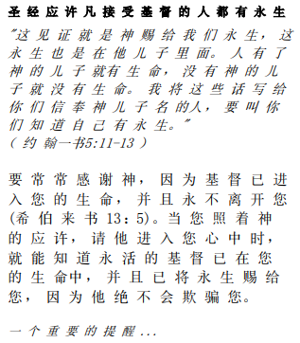
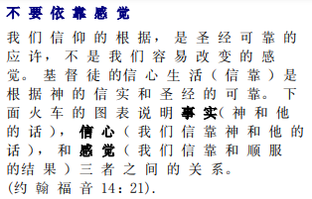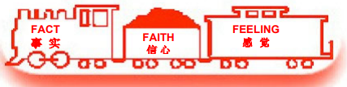
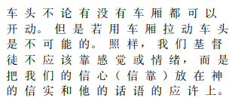
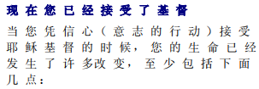

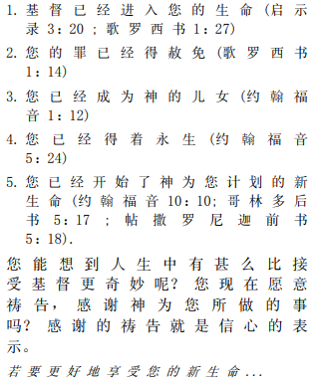
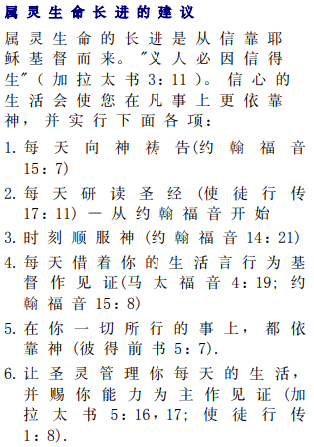

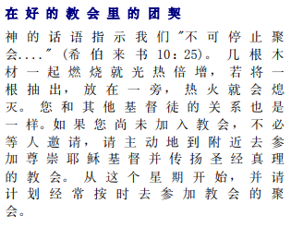

如果你接受基督使徒行传 2:42 事工很想知道。或者，如果您对这些工作表有任何要分享的内容，请告诉我们。

nathand@242ministries.org

