Lesson 7 – Object pronouns

(Lección 7 - Pronombres de objetos)

|  |  |  |
| --- | --- | --- |
| **English** | **español** | **Foto** |
| Me | Me | Boy Young Stand - Free vector graphic on Pixabay |
| You (Singular) | Te | Royalty-Free photo: Man wearing polo shirt while woman wearing ... |
| Him/Her/It | Lo/La | Royalty-free self-portrait photos free download | Pxfuel |
| Us | Nos | People,cartoon,caricature,symmetric,drawing - free image from needpix.com |
| You (plural) | Os | Pronoun you | Public domain vectors |
| Them | Los/Las | Business Men are Talking clipart. Free download transparent .PNG | Creazilla |

Label the object pronoun

(Etiquetar el pronombre del objeto)

|  |  |  |
| --- | --- | --- |
| **Number**  (número) | **Picture (imagen)** | **Answer (Responder)** |
| 1 |  |  |
| 2 |  |  |
| 3 | Stickman,stick figure,cartoon,symbol,action game - free image from  needpix.com |  |
| 4 | 400+ Free Group & Team Vectors - Pixabay |  |
| 5 |  |  |
| 6 | 200+ Free Dog Cartoon & Dog Images - Pixabay |  |

Answers on next page (respuestas en la página siguiente)

1. him
2. them
3. me
4. us
5. you
6. it

Pick the right object pronoun

(Elige el pronombre correcto )

|  |  |
| --- | --- |
| 1. Cartoon soccer player in action free imageLet’s play soccer with Marco. 2. him 3. her 4. me | 1. Bull playing basketball clipart. Free download transparent .PNG | CreazillaCan I play basketball with the bull? 2. her 3. me 4. it |
| 1. Come see Jack and Jill. 2. Family,brother,sister,stick,figures - free image from needpix.comhim 3. them 4. you | 1. Fun,laugh,cartoon,elderly,dancing - free image from needpix.comGrandpa likes to dance with grandma. 2. us 3. them 4. her |
| 1. Come with Carl. 2. it 3. me 4. them   would you please come a little bit closer... | lysander07 | Flickr | 1. Boy Plays with Beach Ball - Vector ImageCan Bobby get the ball? 2. he 3. him 4. you |

Answers on next page (respuestas en la página siguiente)

1. him
2. it
3. them
4. her
5. me
6. you – (no él porque necesita pronombre de objeto no pronombre personal)

Fill in the blank with the correct object pronoun – More Difficult

(Complete el espacio en blanco con el pronombre de objeto correcto -   
Más difícil)

1. How old are _____________________?
2. Let’s go play with Molly and Michelle. Let’s go play with _______________.
3. I am lonely. Come play with ________________.
4. What can you watch Jack do? You can watch ____________ run.
5. Lila and I are friends. You can come play with ________________.
6. The dog got a treat. ________ was a good dog.

Answers on next page (respuestas en la página siguiente)

1. you
2. them
3. me
4. him
5. us
6. It

To try at home (Para probar en casa)

1. Easier - Practice naming people in your family with object pronouns. (Más fácil - Practique nombrar a diferentes personas de su familia con pronombres de objeto.)
2. More difficult - For each of the object pronouns and try to make a sentence. For instance, use him in the sentence “I will watch him play soccer.” Use a translator to figure out the English word if you don’t know it.

(Más difícil - Para cada uno de los pronombres de objeto e intente hacer una oración. Por ejemplo, utilícelo en la oración "Lo veré jugar al fútbol". Utilice un traductor para averiguar la palabra en inglés si no la conoce.

**Please consider donating to Acts 2:42 Ministries (**<https://www.paypal.com/fundraiser/charity/213230>**) to support the free English lessons. Thank you!**

Considere hacer una donación a Acts 2:42 Ministries (<https://www.paypal.com/fundraiser/charity/213230>) para apoyar las lecciones de inglés gratuitas. ¡Gracias!

[How do I get to heaven?](#English" \o "English)

¿Cómo llego al cielo?

كيف أصل إلى الجنة؟

[چگونه به بهشت ​​برسم؟](#فارسی" \o "فارسی)

میں جنت میں کیسے جاؤں؟

[Cennete nasıl gidebilirim?](#Türk" \o "Türk)

[मैं स्वर्ग कैसे पहुँचूँ?](#हिंदी" \o "हिंदी)

我怎样才能上天堂？

English:

<https://peacewithgod.net/>

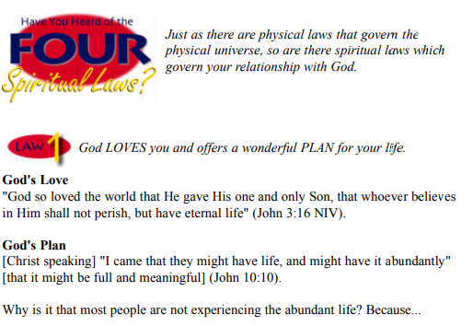

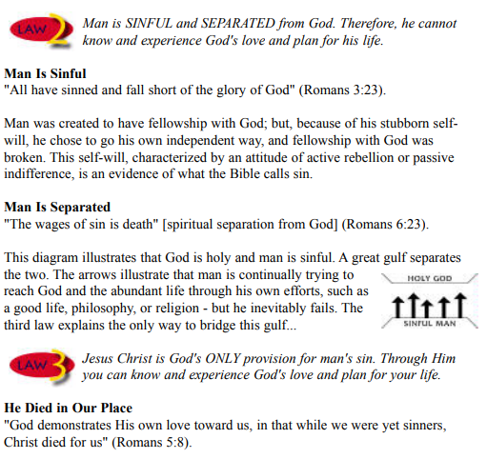

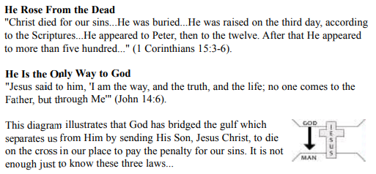

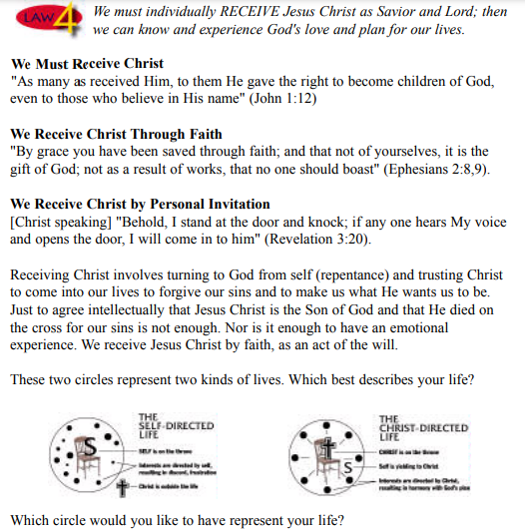

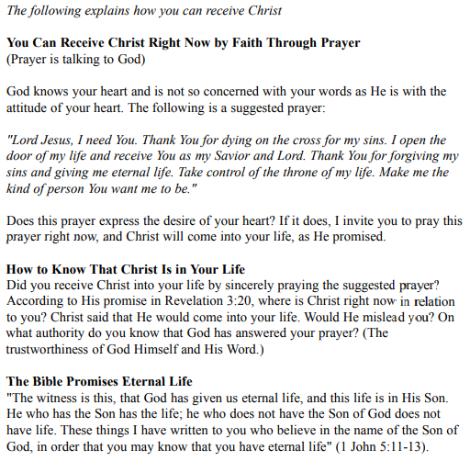

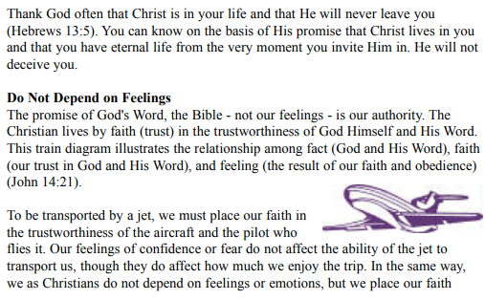

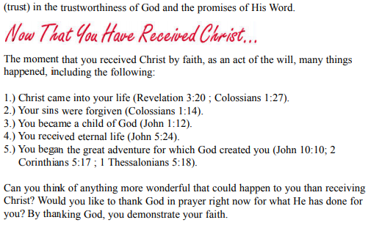

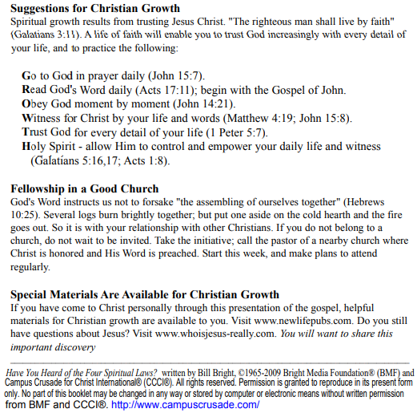

If you accepted Christ Acts 2:42 Ministries would love to know. Or if you have anything to share about these worksheets please let us know. [nathand@242ministries.org](mailto:nathand@242ministries.org)

español:

<https://www.youtube.com/watch?v=NRUqXwqTA8w>



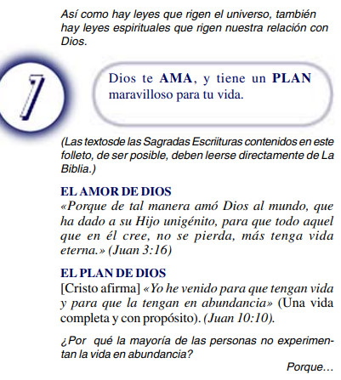

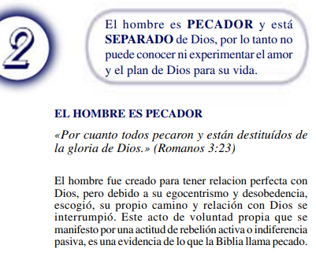

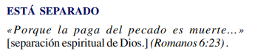

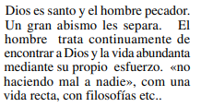

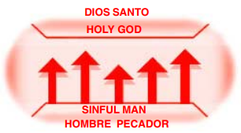



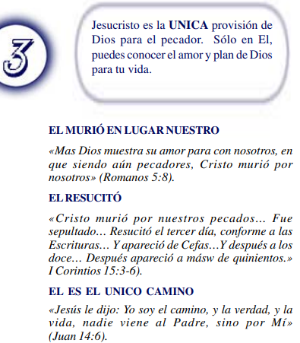

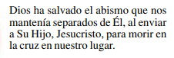

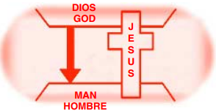



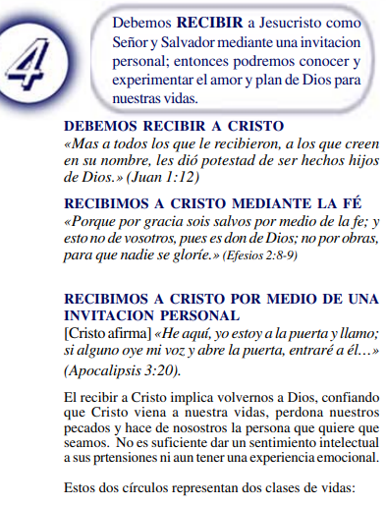

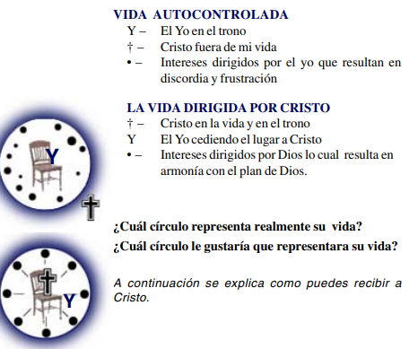

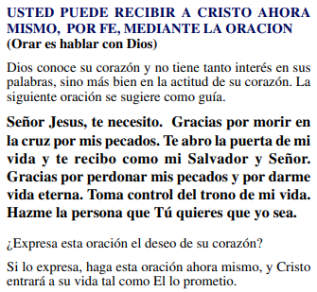

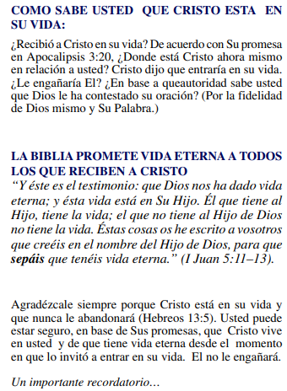

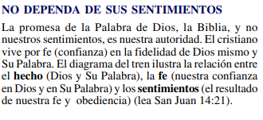

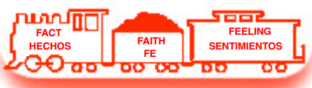

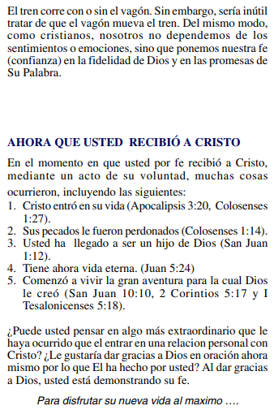

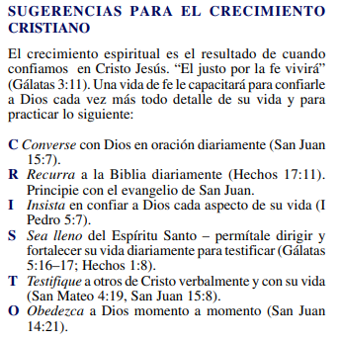

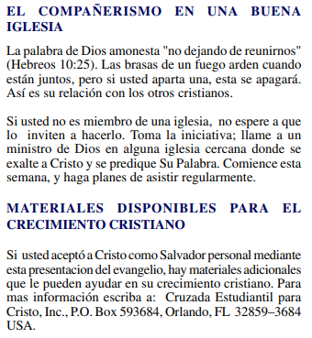

(Si aceptaste a Cristo Hechos 2:42 a Ministerios le encantaría saberlo. O si tiene algo que compartir sobre estas hojas de trabajo, háganoslo saber.)

[nathand@242ministries.org](mailto:nathand@242ministries.org)

عربى:

<https://www.youtube.com/watch?v=ePa_MElCi68>

<https://www.youtube.com/watch?v=o0GFYMPArW0>







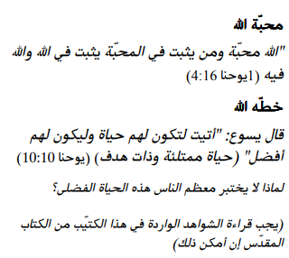

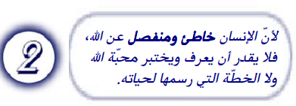

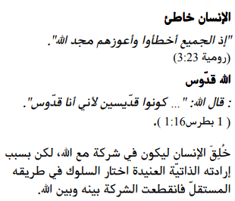

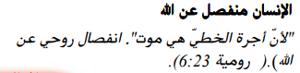

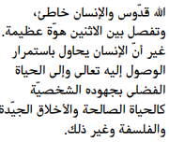

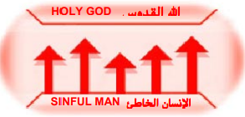



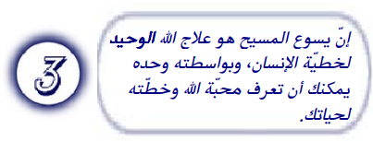

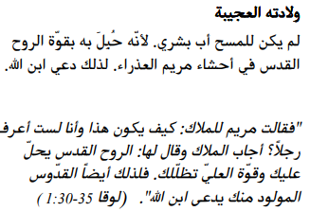

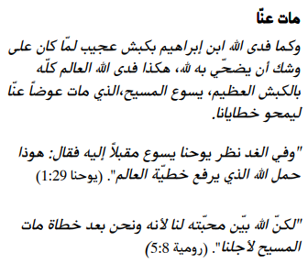

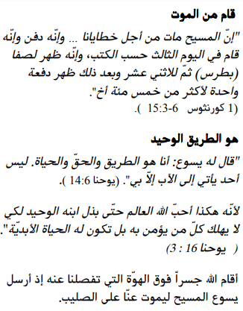

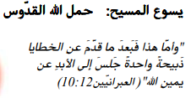

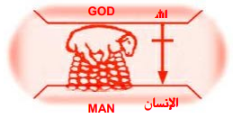





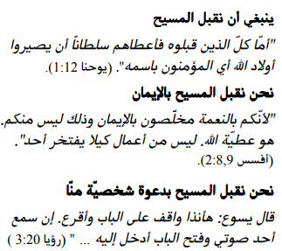

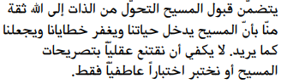



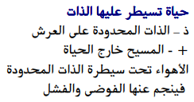

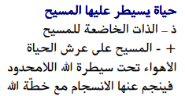

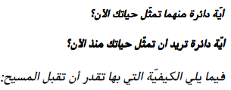

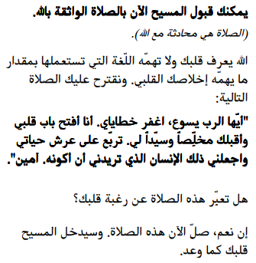

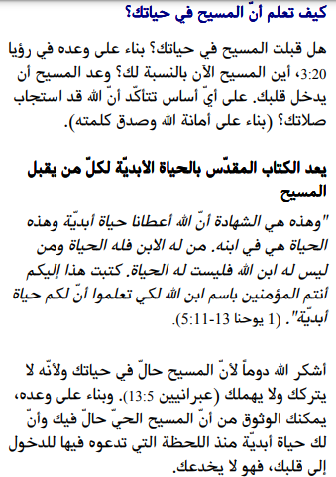

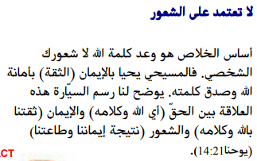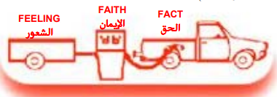

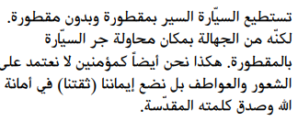

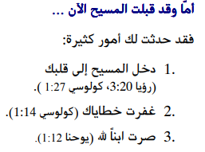

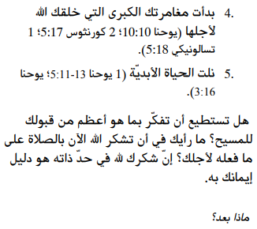

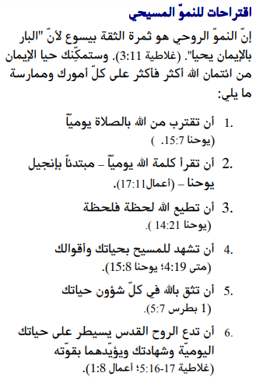

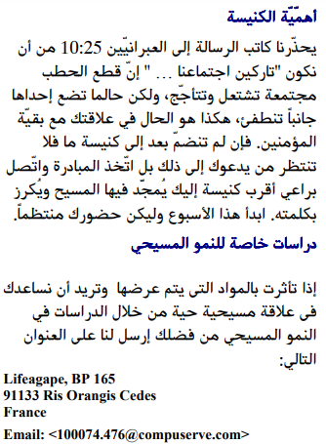

إذا قبلت المسيح فإن الخدمات تحب أن تعرف. أو إذا كان لديك أي شيء تريد مشاركته حول أوراق العمل هذه ، فيرجى إخبارنا بذلك.

[nathand@242ministries.org](mailto:nathand@242ministries.org)

فارسی:<https://www.youtube.com/watch?v=eWLsQ0DTsq0&t=12s>



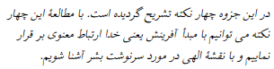



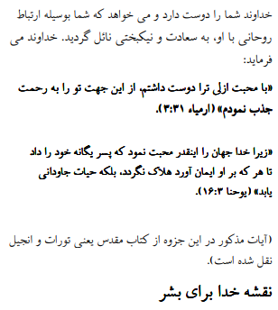

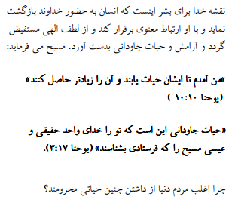



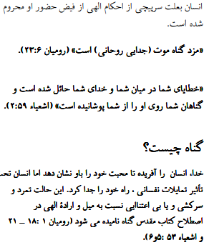

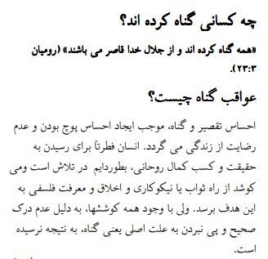







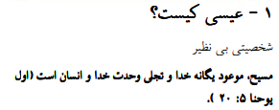

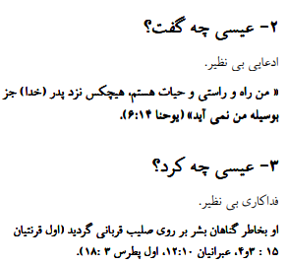

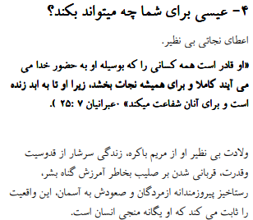

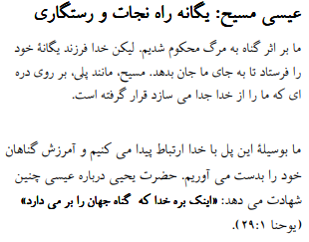

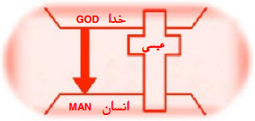





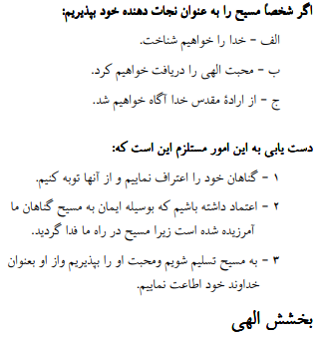

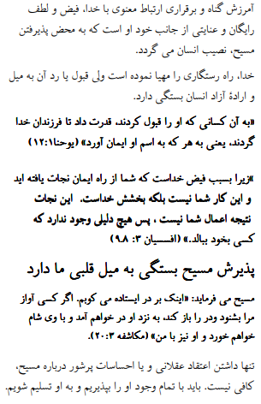

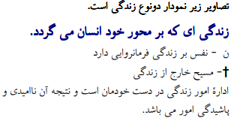



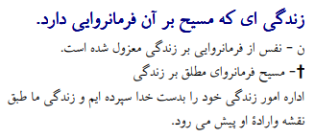





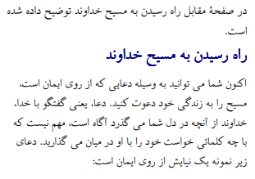

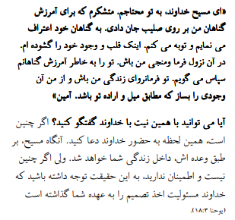

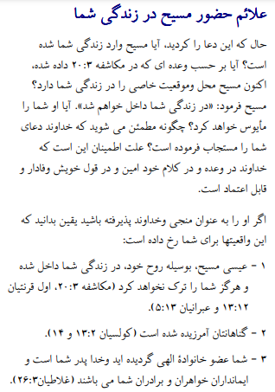

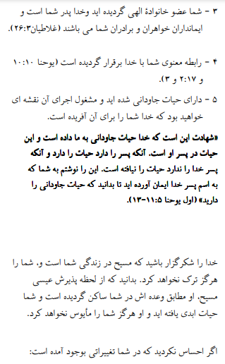

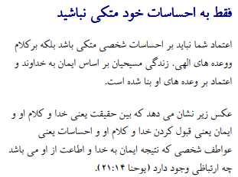

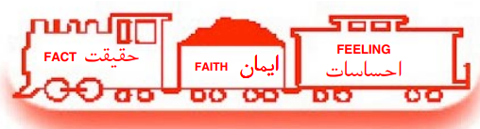

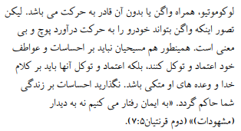

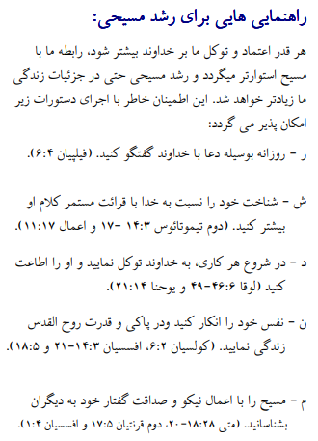



اگر مسیح را پذیرفتید اعمال رسولان 2:42 وزارتخانه ها دوست دارند بدانند. یا اگر چیزی برای به اشتراک گذاشتن در مورد این کاربرگ ها دارید ، لطفاً به ما اطلاع دهید

[nathand@242ministries.org](mailto:nathand@242ministries.org)

اردو:

<https://www.youtube.com/watch?v=6-GclzuUbxY>

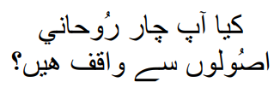

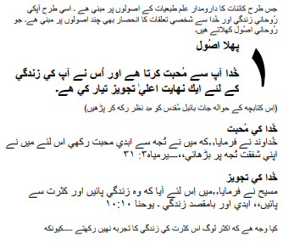

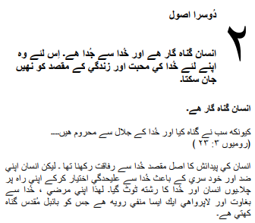

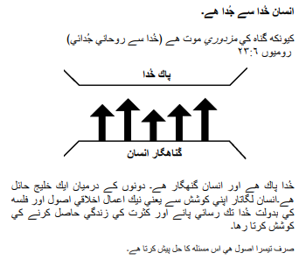

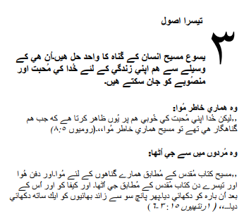

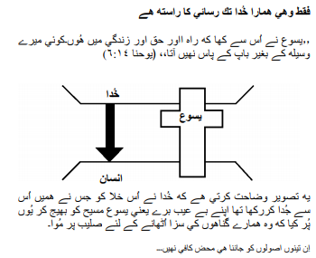

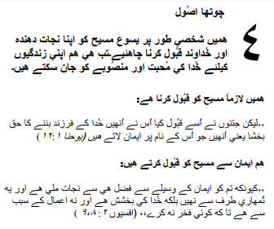

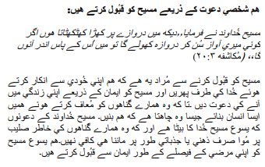

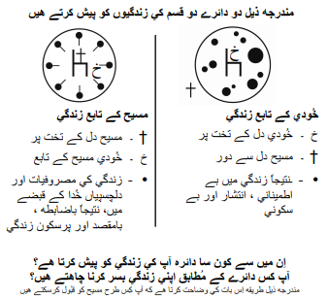

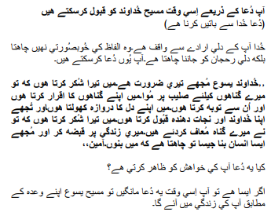

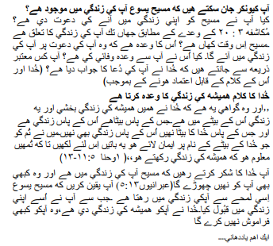

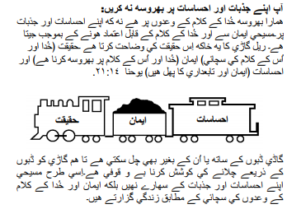

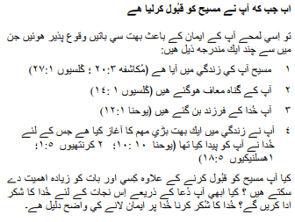

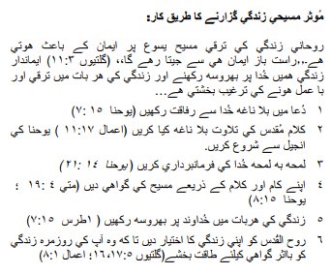

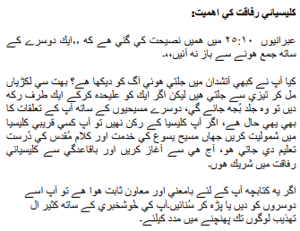

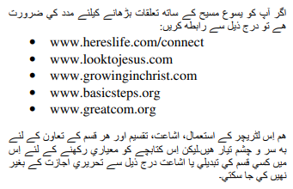

اگر آپ نے مسیح کے اعمال کو قبول کیا تو 2:42 وزارتیں جاننا پسند کریں گی۔ یا اگر آپ کے پاس ان ورک شیٹس کے بارے میں کچھ شیئر کرنا ہے تو براہ کرم ہمیں بتائیں۔

[nathand@242ministries.org](mailto:nathand@242ministries.org)

Türk:

<https://www.youtube.com/watch?v=6YwHd_PwOOQ>







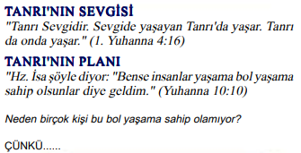



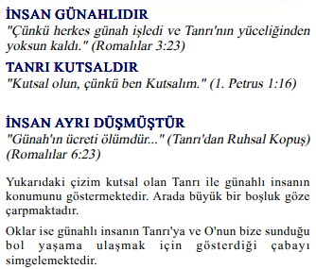

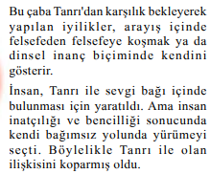

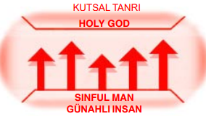



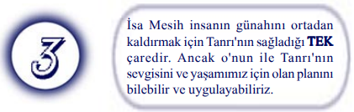

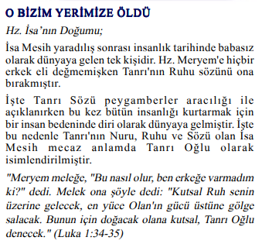



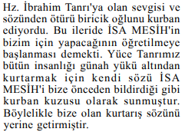

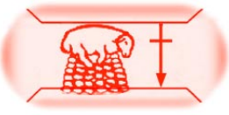

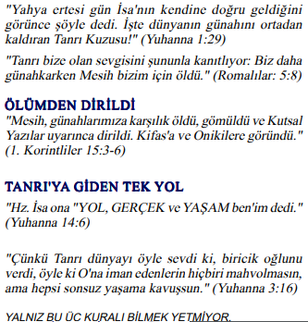

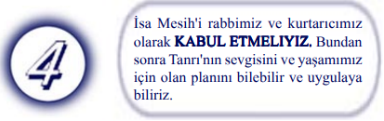

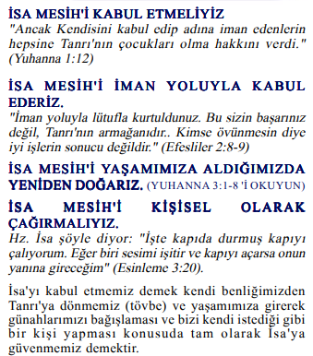

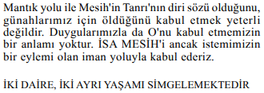

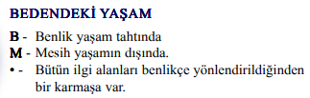

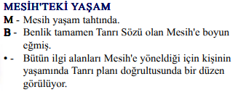

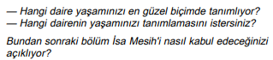

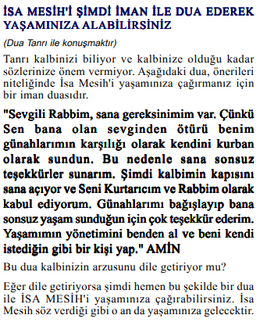

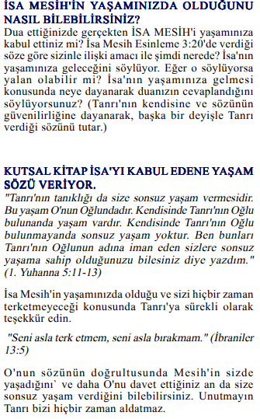

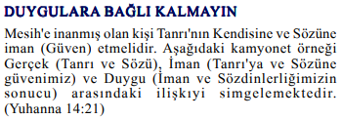



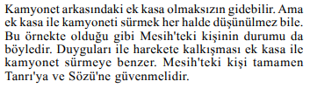

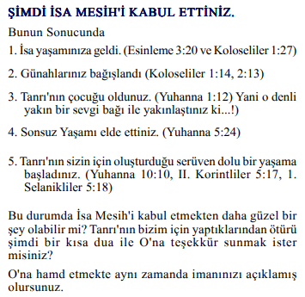

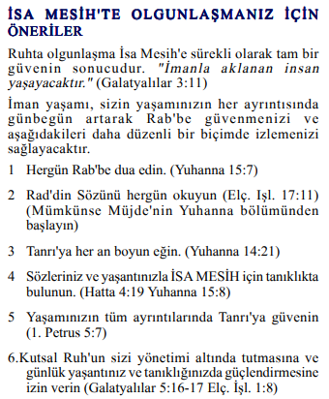

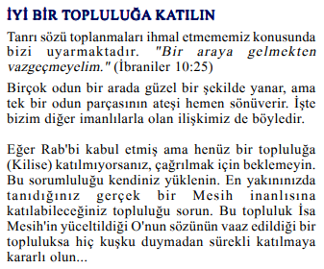

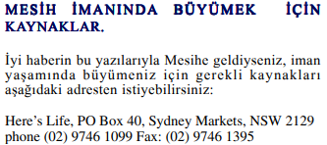

Mesih'in Elçilerinin İşleri 2:42'yi kabul ettiyseniz, Bakanlıklar bilmek ister. Veya bu çalışma sayfaları hakkında paylaşmak istediğiniz bir şey varsa lütfen bize bildirin.

[nathand@242ministries.org](mailto:nathand@242ministries.org)

हिंदी:

<https://www.youtube.com/watch?v=NR7AieVQI2A>

<https://www.youtube.com/watch?v=nmHla8doL5o>

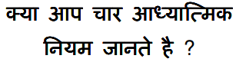

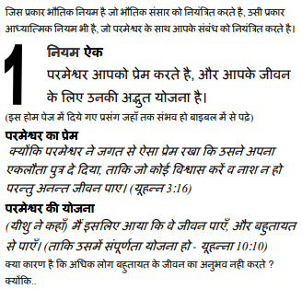

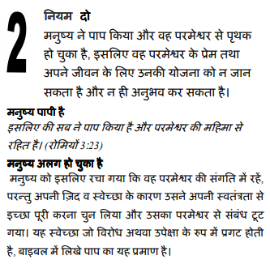

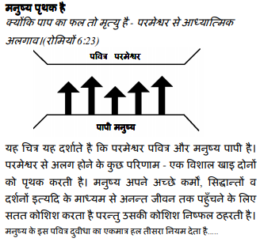

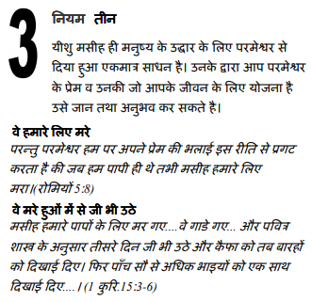

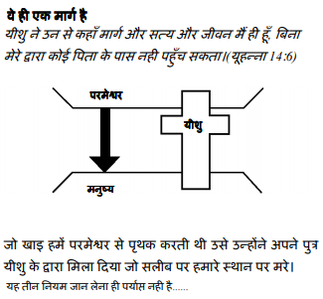

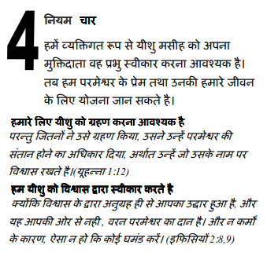

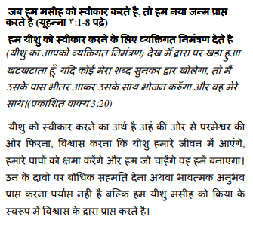

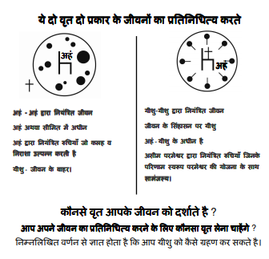

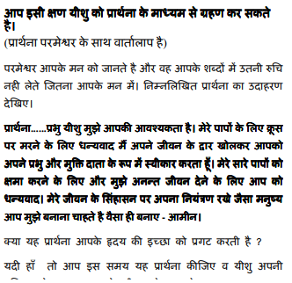

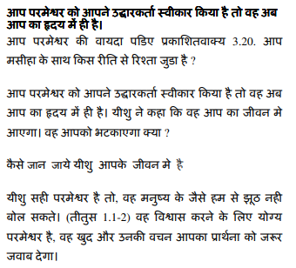

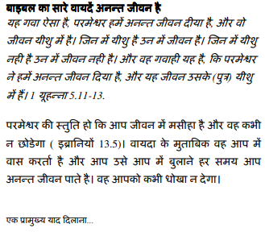

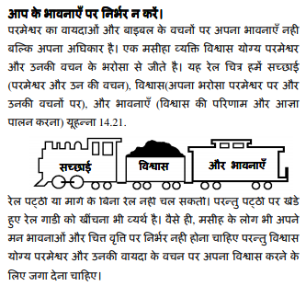

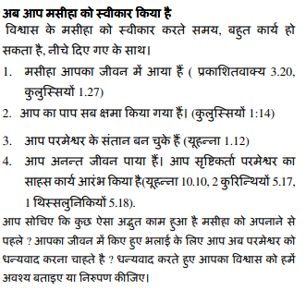

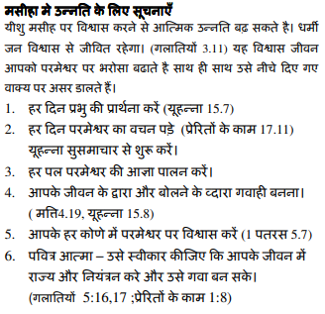

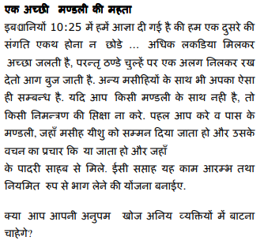

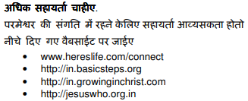

यदि आप मसीह के कामों को स्वीकार करते हैं प्रेरितों 2:42 मंत्रालयों को जानना अच्छा लगेगा। या यदि आपके पास इन कार्यपत्रकों के बारे में साझा करने के लिए कुछ है तो कृपया हमें बताएं।

[nathand@242ministries.org](mailto:nathand@242ministries.org)

中国人:

<https://www.youtube.com/watch?v=ebaT4PvcUEc>









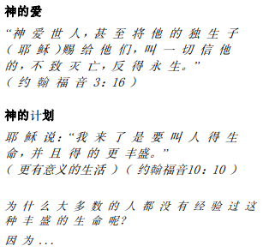



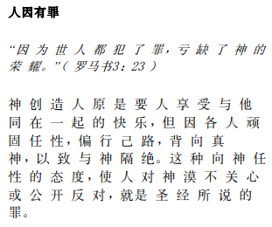



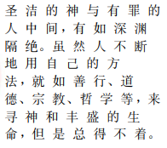





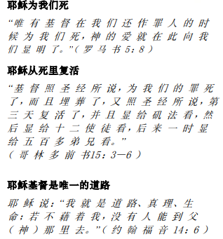

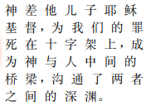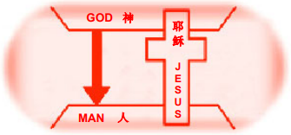





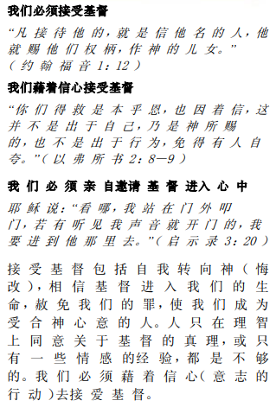

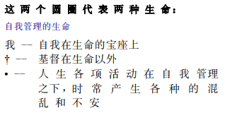

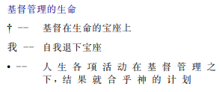

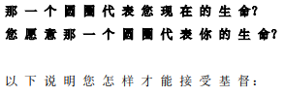

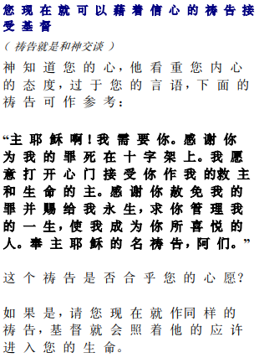

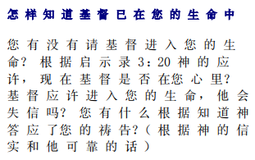

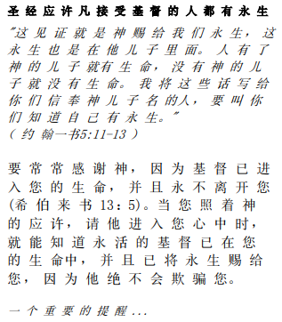

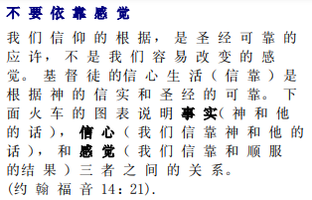

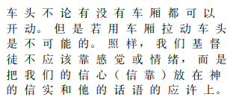

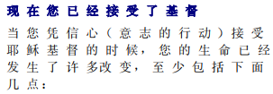

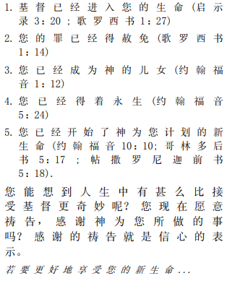

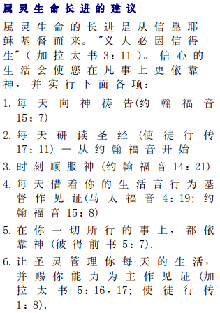

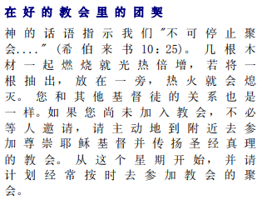



如果你接受基督使徒行传 2:42 事工很想知道。或者，如果您对这些工作表有任何要分享的内容，请告诉我们。

[nathand@242ministries.org](mailto:nathand@242ministries.org)