Review sheets for Lessons 1 to 9

(Revise las hojas de las lecciones 1 a 9)

Personal pronouns (pronombres personales)

|  |  |  |
| --- | --- | --- |
| **English** | **español** | **Foto** |
| I | Yo | Boy Young Stand - Free vector graphic on Pixabay |
| You (Singular) | Tú | Royalty-Free photo: Man wearing polo shirt while woman wearing ... |
| He/She | Él/Ella/Usted | Royalty-free self-portrait photos free download | Pxfuel |
| We | Nosotros | We pronoun | Public domain vectors |
| You (plural) | Vosotros | Pronoun you | Public domain vectors |
| They | Ellos/Ellas/Ustedes | C:\Users\natha\Desktop\pronoun-they.jpg |

Family Vocabulary (Vocabulario familiar)

|  |  |  |
| --- | --- | --- |
| **English** | **español** | **Foto** |
| Father/Dad | padre/papá | African Father | Free SVG |
| Mother/Mom | Madre/mamá | Mother and Daughter (#3) | Free SVG |
| Brother | Hermano | C:\Users\natha\Desktop\download.png |
| Sister | Hermana | C:\Users\natha\Desktop\download.png |
| Grandfather/Grandpa | Abuelo | C:\Users\natha\Desktop\grandpa-3937506_1280.png |
| Grandmother/Grandma | Abuela | 80+ Free Grandma & Grandmother Illustrations - Pixabay |

To be (am, is, are)

(Ser/Estar)

|  |  |  |
| --- | --- | --- |
| **English** | **español** | **Foto** |
| I am | Yo soy  Yo estoy | Boy Young Stand - Free vector graphic on Pixabay |
| You (Singular) are | Tú eres  Tú estás | Royalty-Free photo: Man wearing polo shirt while woman wearing ... |
| He is  She is  It is | Él es OR Él está Ella es OR Ella está  Usted es/está  Es OR está | Royalty-free self-portrait photos free download | Pxfuel |
| We are | Nosotros somos  Nosotros estamos | We pronoun | Public domain vectors |
| You (plural) are | Vosotros sois  Vosotros estáis | Pronoun you | Public domain vectors |
| They are | Ellos son OR Ellos están  Ellas son OR Ellas están  Ustedes son/están  Son OR Están | C:\Users\natha\Desktop\pronoun-they.jpg |

Emotions (Emociones)

|  |  |  |
| --- | --- | --- |
| **English** | **español** | **Foto** |
| Happy | Feliz / Contento(a) | Smile Smiling Face - Free image on Pixabay |
| Sad | Triste | C:\Users\natha\Desktop\download.png |
| Mad or Angry | Enojado(a) | Angry Icon of Flat style - Available in SVG, PNG, EPS, AI & Icon fonts |
| Fear or Scared | Miedo o Asustado(a) | Cartoon scared man free image |
| Surprised | Sorprendido(a) | Surprised bee clipart. Free download transparent .PNG | Creazilla |
| Excited | Emocionado(a) | Happy cartoon Goofy free image |
| Tired or Sleepy | Cansado(a) o soñoliento(a) | Sleepy Cartoon Face Sco free image |
| Hungry | hambriento(a) | 90+ Free Hungry & Food Illustrations - Pixabay |
| Sick | Enfermo(a) | Sick Boy Cartoon N5 free image |

Object pronouns (Pronombres de objetos)

|  |  |  |
| --- | --- | --- |
| **English** | **español** | **Foto** |
| Me | Me | Boy Young Stand - Free vector graphic on Pixabay |
| You (Singular) | Te | Royalty-Free photo: Man wearing polo shirt while woman wearing ... |
| Him/Her/It | Lo/La | Royalty-free self-portrait photos free download | Pxfuel |
| Us | Nos | People,cartoon,caricature,symmetric,drawing - free image from needpix.com |
| You (plural) | Os | Pronoun you | Public domain vectors |
| Them | Los/Las | Business Men are Talking clipart. Free download transparent .PNG | Creazilla |

Adjectives (Adjetivos)

|  |  |  |
| --- | --- | --- |
| **English** | **español** | **Foto** |
| big or large | grande | Elephant,cartoon,baby elephant,funny,big eyes - free image from needpix.com |
| small or little | pequeño(a) | SnappyGoat.com - Free Public Domain Images - SnappyGoat.com-  mouse-rodent-animal-small-pet-311206.svg |
| good | bueno(a) | 300 Free Thumbs Up Illustrations and Graphic - Pixabay - Pixabay |
| bad | malo(a) | Samuel Smiley Smiliy Thumbs - Free image on Pixabay |
| long | largo(a) | Cartoon Wiener Dog Dachshund - Vector Image |
| tall | alto(a) | Giraffe,neck,cartoon,wildlife,safari - free image from needpix.com |
| short | corto(a) o bajo(a) | Tall Person Short Cartoon drawing free image |
| young | joven | Baby Boy Blue - Free vector graphic on Pixabay |
| old | viejo | Cartoon old man with a cane free image |

**Please consider donating to Acts 2:42 Ministries (**<https://www.paypal.com/fundraiser/charity/213230>**) to support the free English lessons. Thank you!**

Considere hacer una donación a Acts 2:42 Ministries (<https://www.paypal.com/fundraiser/charity/213230>) para apoyar las lecciones de inglés gratuitas. ¡Gracias!

[How do I get to heaven?](#English" \o "English)

[¿Cómo llego al cielo?](#español)

[كيف أصل إلى الجنة؟](#عربى)

[چگونه به بهشت ​​برسم؟](#فارسی" \o "فارسی)

[میں جنت میں کیسے جاؤں؟](#اردو)

[Cennete nasıl gidebilirim?](#Türk" \o "Türk)

[मैं स्वर्ग कैसे पहुँचूँ?](#हिंदी" \o "हिंदी)

[我怎样才能上天堂？](#中国人)

English:

<https://peacewithgod.net/>

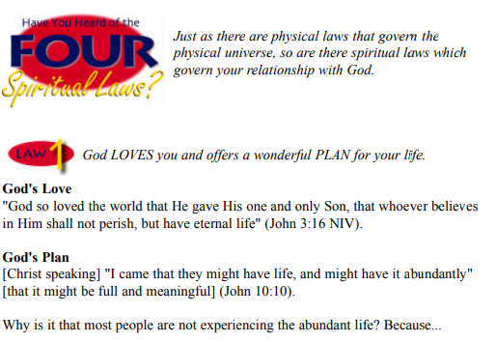

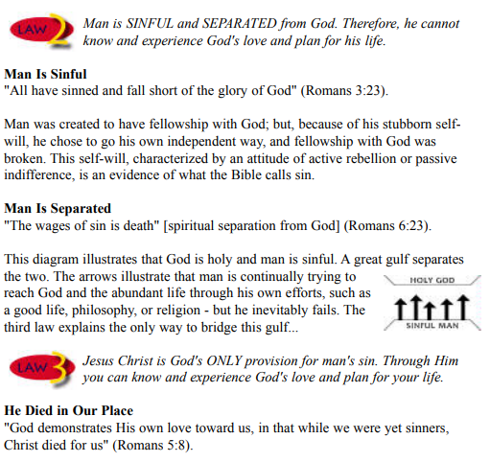

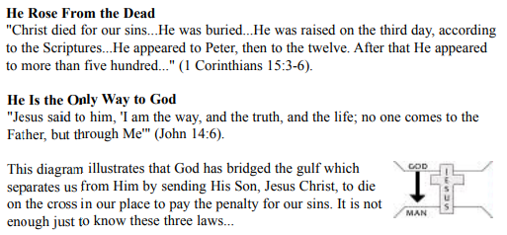

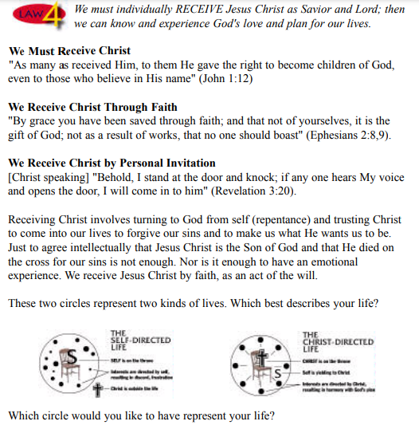

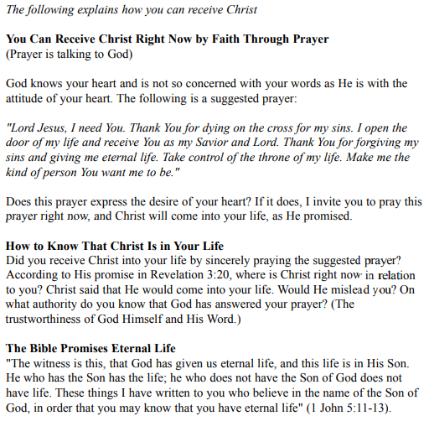

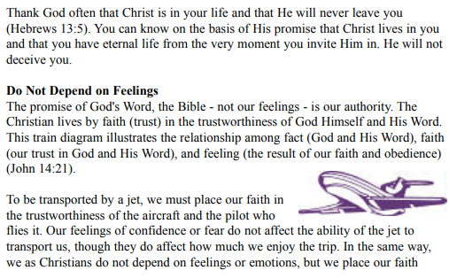



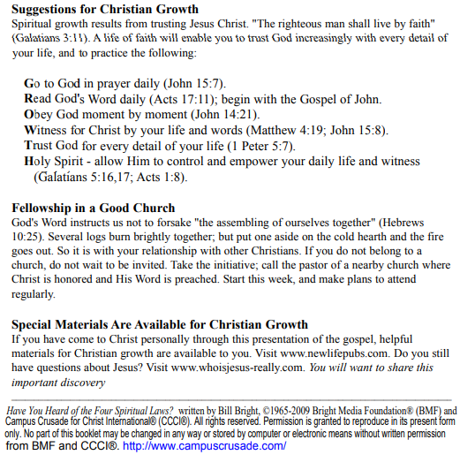

If you accepted Christ Acts 2:42 Ministries would love to know. Or if you have anything to share about these worksheets please let us know. [nathand@242ministries.org](mailto:nathand@242ministries.org)

español:

<https://www.youtube.com/watch?v=NRUqXwqTA8w>



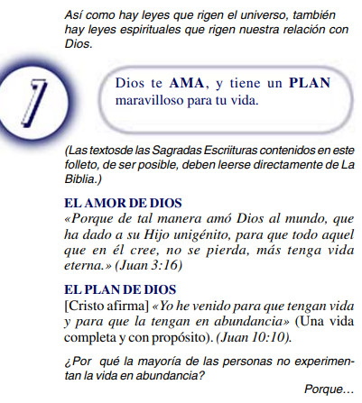

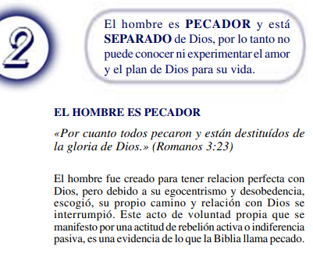

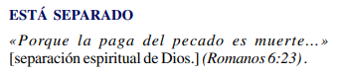

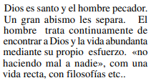

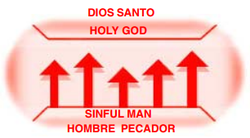



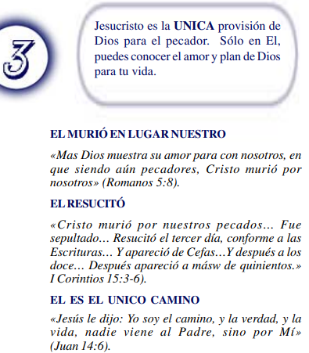

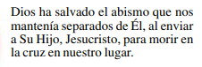

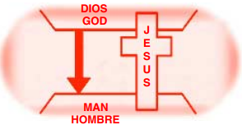



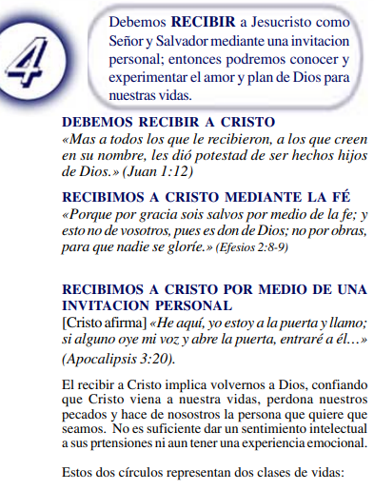

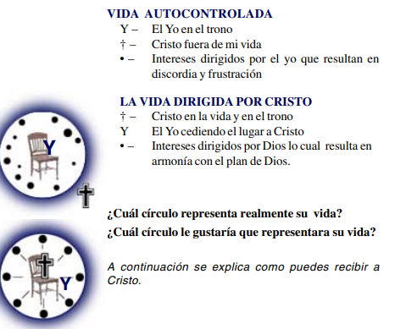

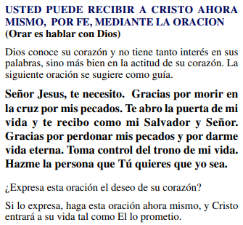

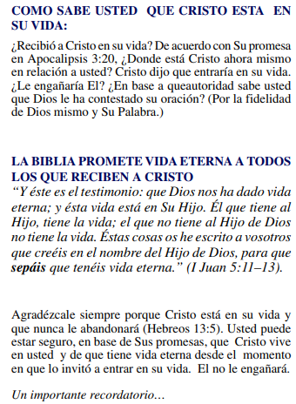

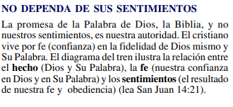

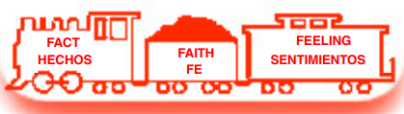

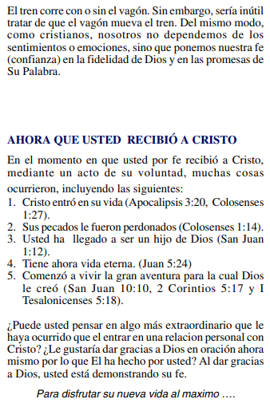

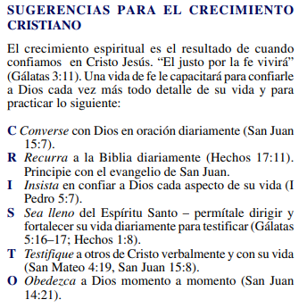

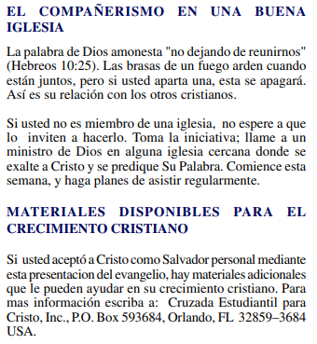

(Si aceptaste a Cristo Hechos 2:42 a Ministerios le encantaría saberlo. O si tiene algo que compartir sobre estas hojas de trabajo, háganoslo saber.)

[nathand@242ministries.org](mailto:nathand@242ministries.org)

عربى:

<https://www.youtube.com/watch?v=ePa_MElCi68>

<https://www.youtube.com/watch?v=o0GFYMPArW0>







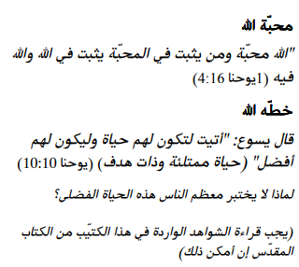

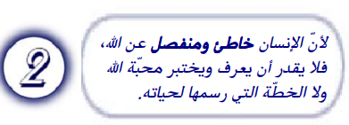

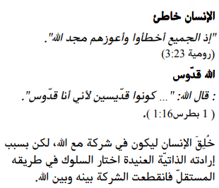

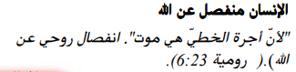

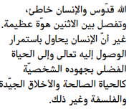

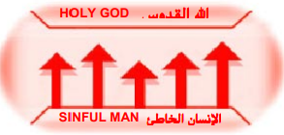



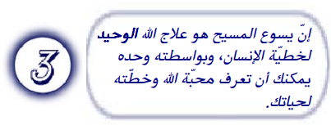

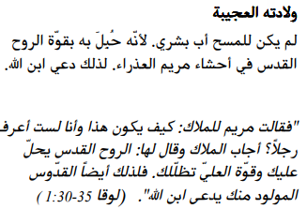

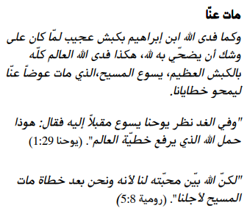

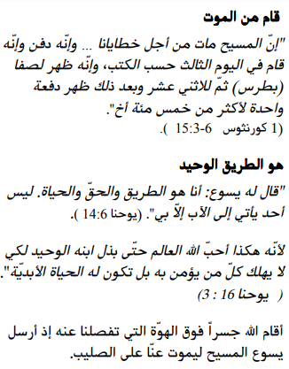

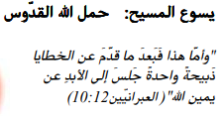

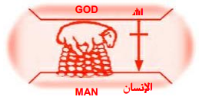





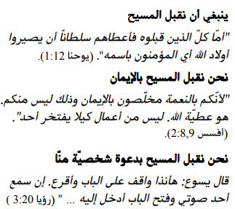

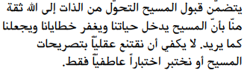



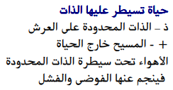

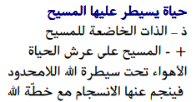

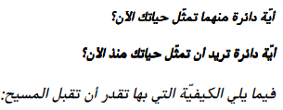

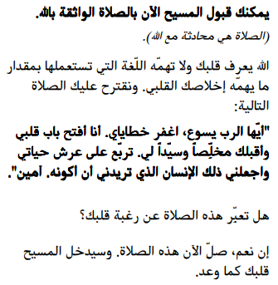

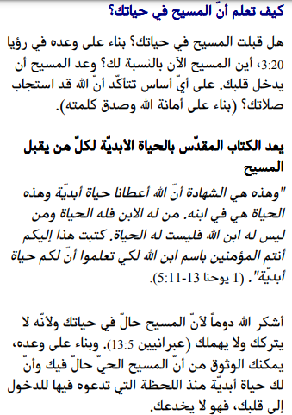

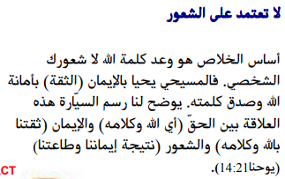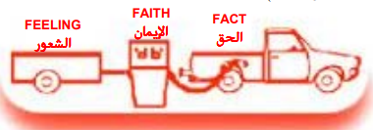

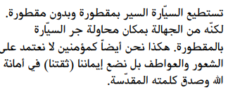

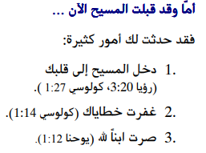

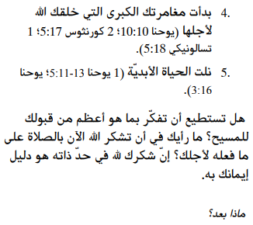

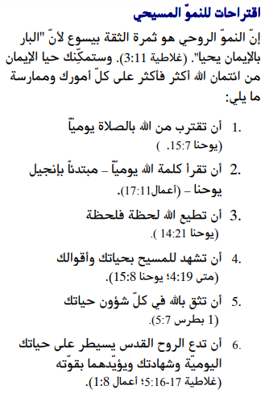

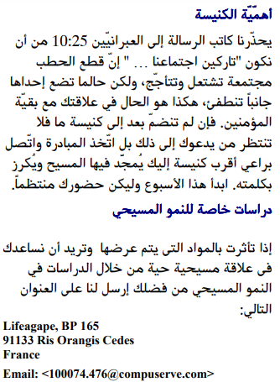

إذا قبلت المسيح فإن الخدمات تحب أن تعرف. أو إذا كان لديك أي شيء تريد مشاركته حول أوراق العمل هذه ، فيرجى إخبارنا بذلك.

[nathand@242ministries.org](mailto:nathand@242ministries.org)

فارسی:<https://www.youtube.com/watch?v=eWLsQ0DTsq0&t=12s>



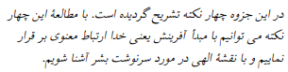



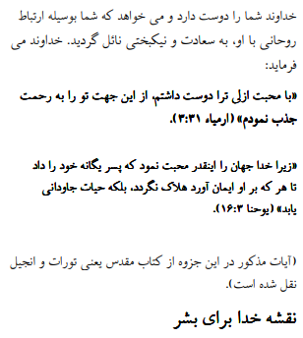

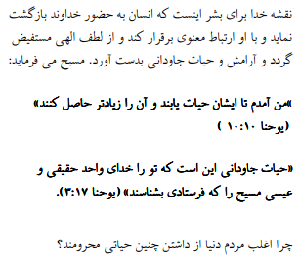



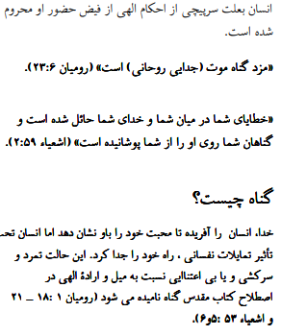

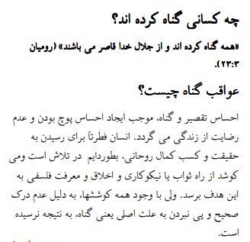

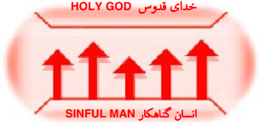





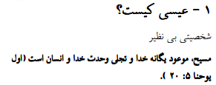

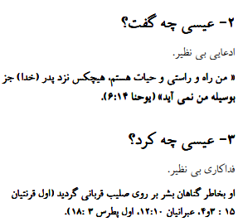

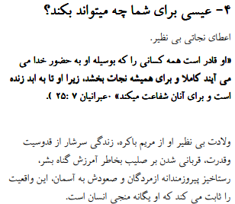

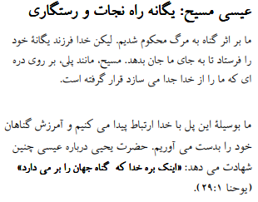

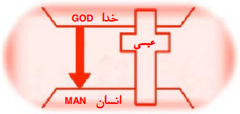





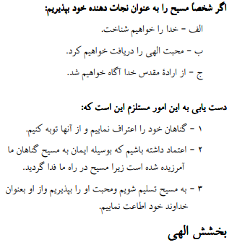

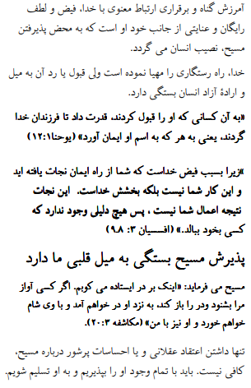

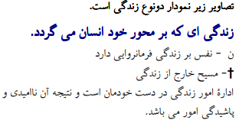



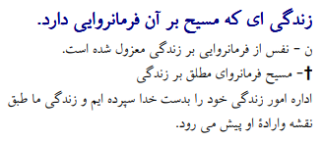





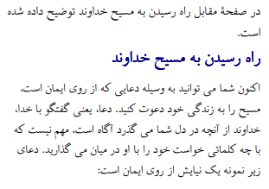

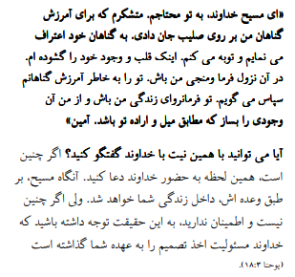

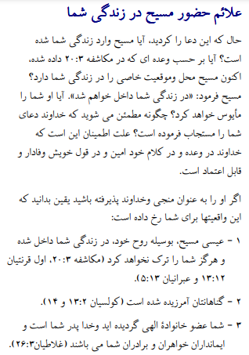

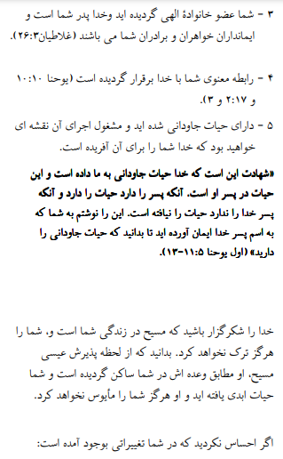

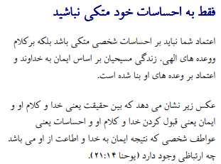

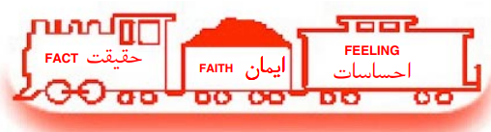

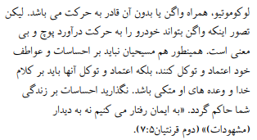

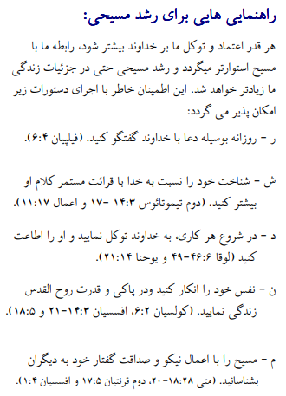

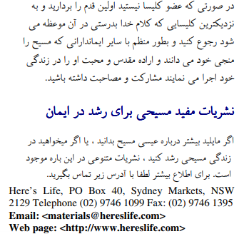

اگر مسیح را پذیرفتید اعمال رسولان 2:42 وزارتخانه ها دوست دارند بدانند. یا اگر چیزی برای به اشتراک گذاشتن در مورد این کاربرگ ها دارید ، لطفاً به ما اطلاع دهید

[nathand@242ministries.org](mailto:nathand@242ministries.org)

اردو:

<https://www.youtube.com/watch?v=6-GclzuUbxY>

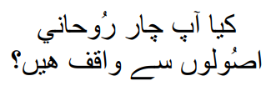

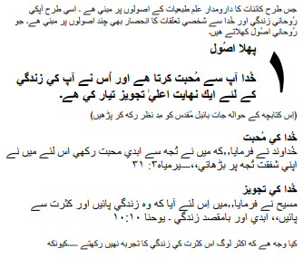

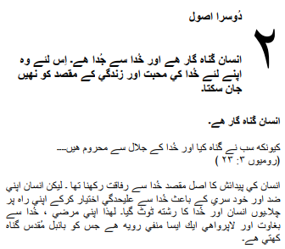

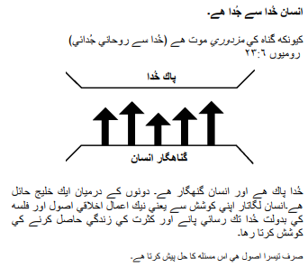

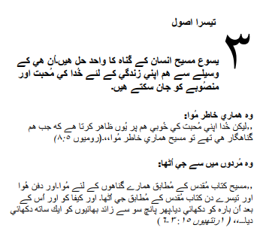

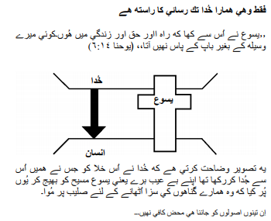

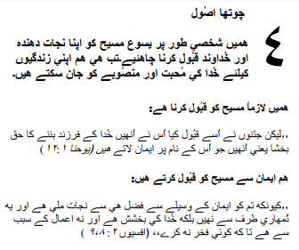

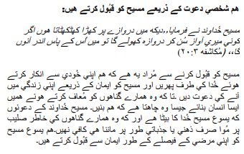

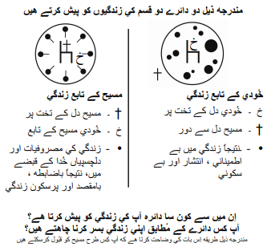

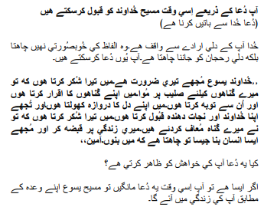

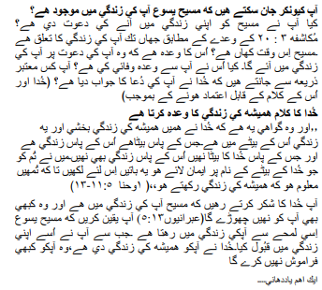

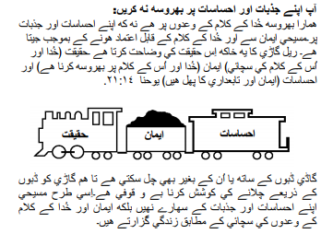

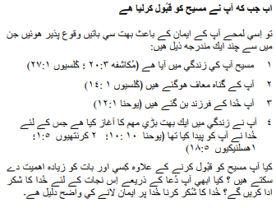

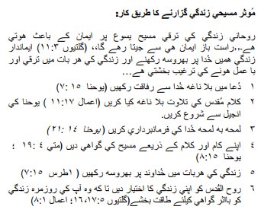

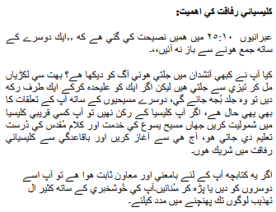

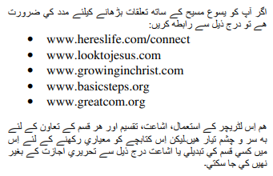

اگر آپ نے مسیح کے اعمال کو قبول کیا تو 2:42 وزارتیں جاننا پسند کریں گی۔ یا اگر آپ کے پاس ان ورک شیٹس کے بارے میں کچھ شیئر کرنا ہے تو براہ کرم ہمیں بتائیں۔

[nathand@242ministries.org](mailto:nathand@242ministries.org)

Türk:

<https://www.youtube.com/watch?v=6YwHd_PwOOQ>





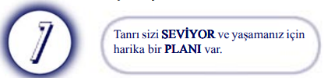

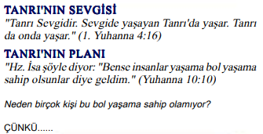

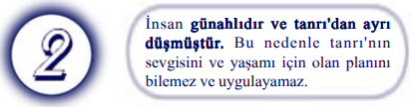

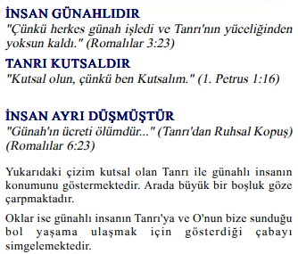

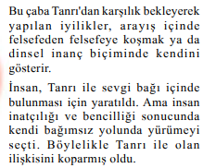

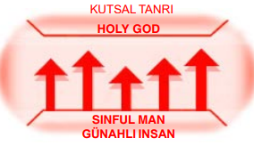



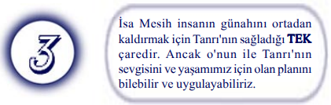

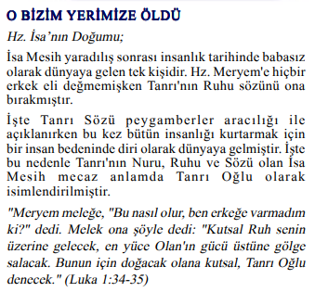



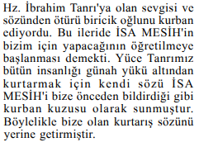

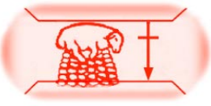

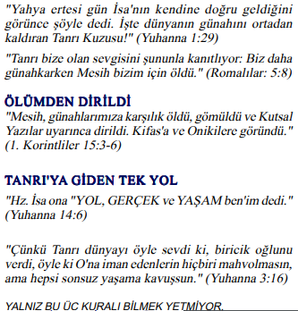

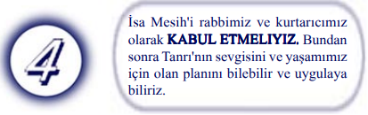

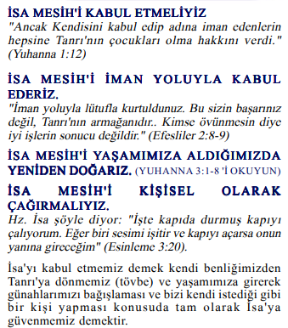

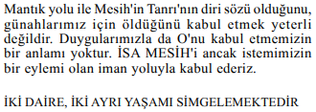

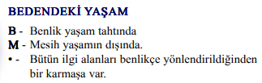

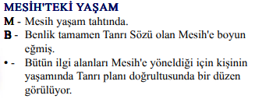

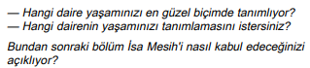

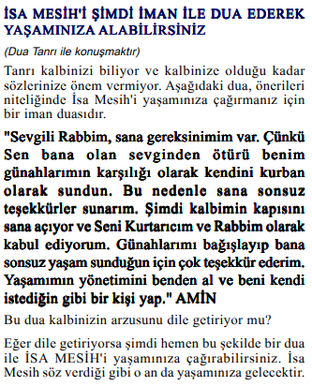

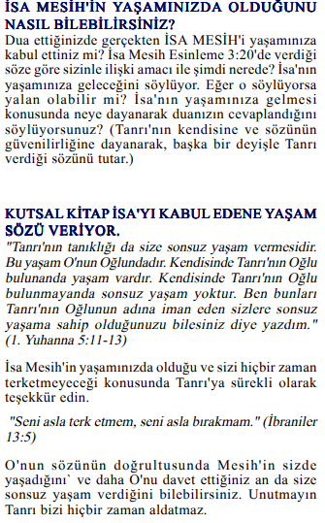

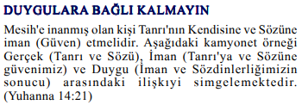

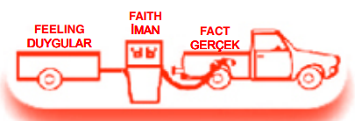

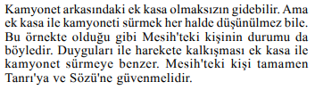

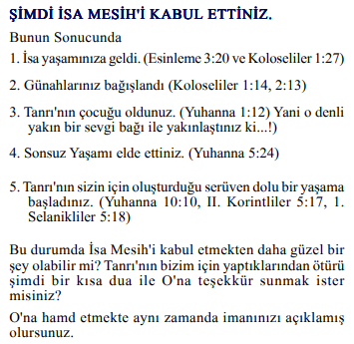

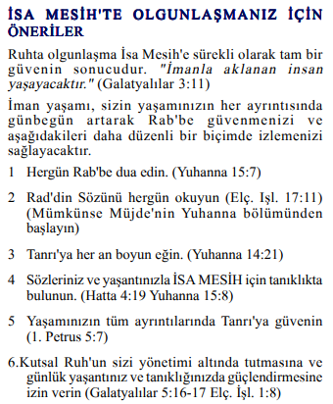

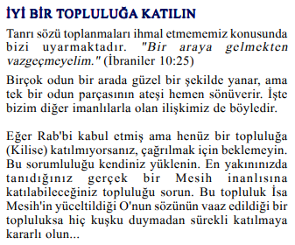

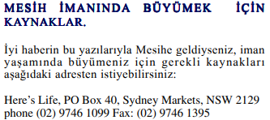

Mesih'in Elçilerinin İşleri 2:42'yi kabul ettiyseniz, Bakanlıklar bilmek ister. Veya bu çalışma sayfaları hakkında paylaşmak istediğiniz bir şey varsa lütfen bize bildirin.

[nathand@242ministries.org](mailto:nathand@242ministries.org)

हिंदी:

<https://www.youtube.com/watch?v=NR7AieVQI2A>

<https://www.youtube.com/watch?v=nmHla8doL5o>

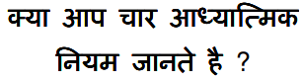

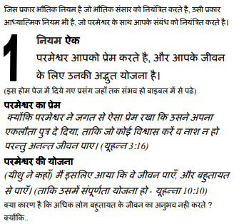

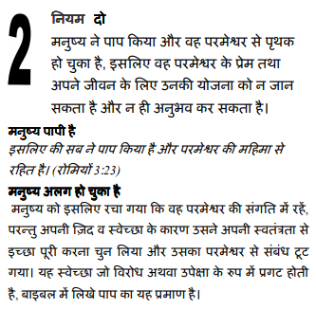

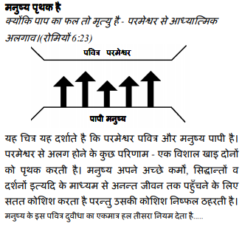

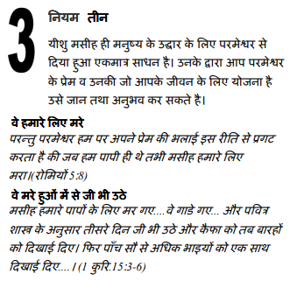

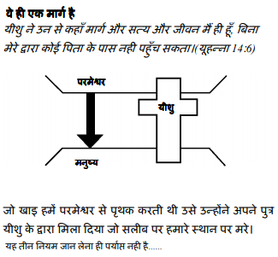

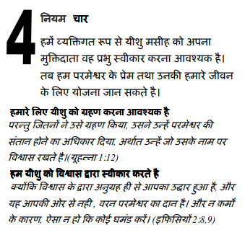

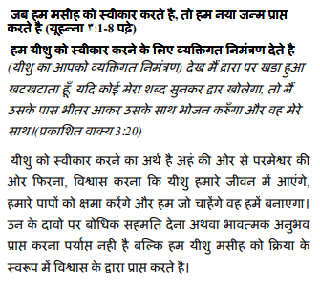

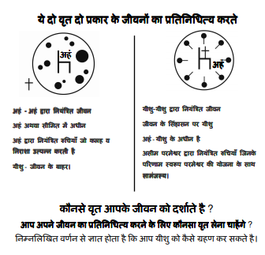

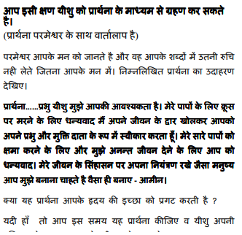

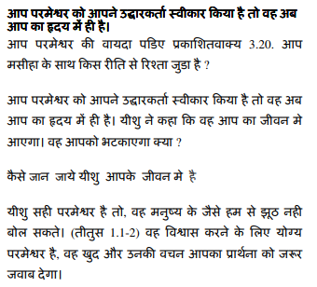

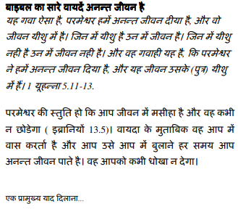

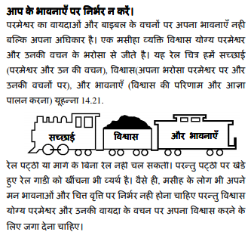

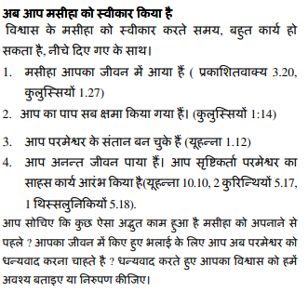

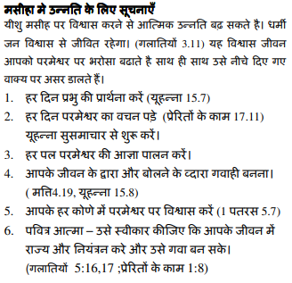

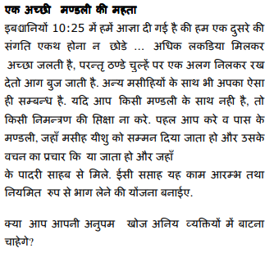

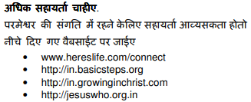

यदि आप मसीह के कामों को स्वीकार करते हैं प्रेरितों 2:42 मंत्रालयों को जानना अच्छा लगेगा। या यदि आपके पास इन कार्यपत्रकों के बारे में साझा करने के लिए कुछ है तो कृपया हमें बताएं।

[nathand@242ministries.org](mailto:nathand@242ministries.org)

中国人:

<https://www.youtube.com/watch?v=ebaT4PvcUEc>









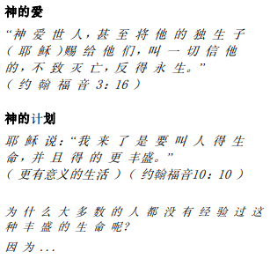



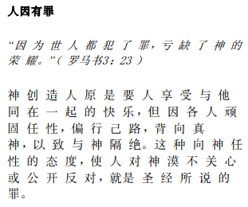

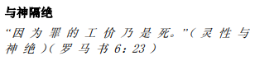

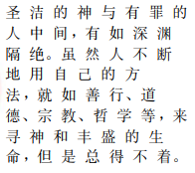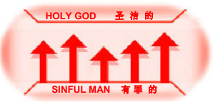





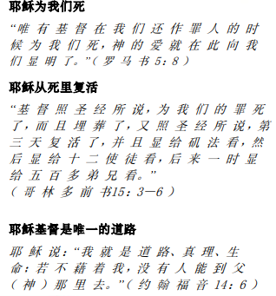

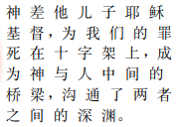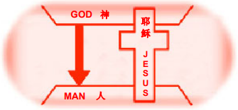





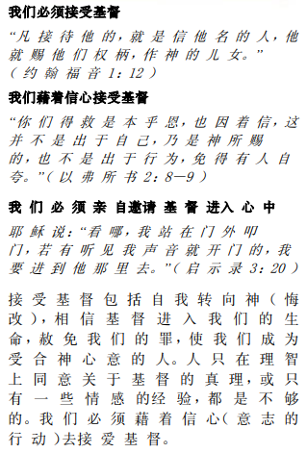

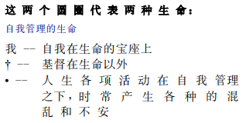

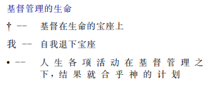

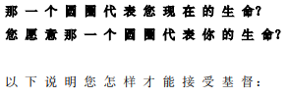

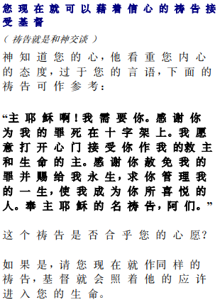

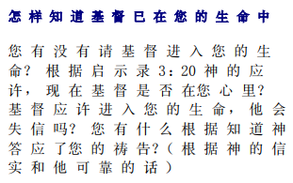

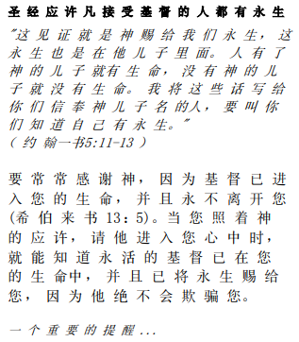

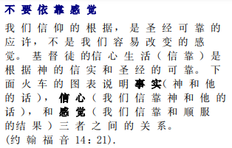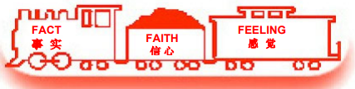

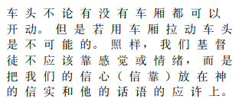

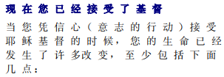

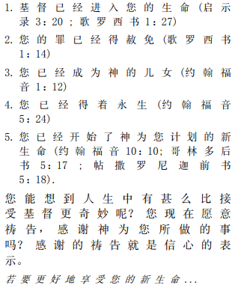

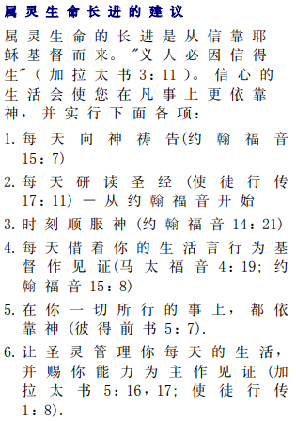

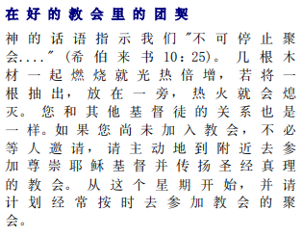



如果你接受基督使徒行传 2:42 事工很想知道。或者，如果您对这些工作表有任何要分享的内容，请告诉我们。

[nathand@242ministries.org](mailto:nathand@242ministries.org)